## Designing a Data Model in Power BI Desktop

**Lab Time**: 60 minutes

**Lab Folder**: C:\Student\Modules\03_DataModeling\Lab

**Lab Overview**: In this set of lab exercises, you will continue to work on the Power BI Desktop project you started in the previous lab. At this point, you have already imported Wingtip sales data from a SQL Azure database and transformed it using the Power Query features of Power BI Desktop to create a starting point for the data model associated with your project. In this lab you will begin to leverage the Power Pivot features of Power BI Desktop to enhance this data model by adding calculated columns and calculated fields. Along the way, you will add pages and visuals to a Power BI Desktop report so you can see the effects of your modeling efforts.

**Lab Dependencies:** This lab assumes you have completed the previous lab titled in which you created a Power BI Desktop project named **Wingtip Sales Analysis.pbix**. In the previous lab you should have imported data into the data model using data from the **WingtipSalesDB** database in SQL Azure and transformed the data into a schema that is better suited for data modeling and analysis. If you would like to begin work on this lab without first completing the previous lab, use the Windows Explorer to copy the lab solution file named **Wingtip Sales Analysis.pbix** which is located in the student folder at **C:\Student\Modules\02_Queries\Lab\** into the folder at **C:\Student\Projects**.

### Exercise 1: Extending the Data Model by Creating Calculated Columns

In this exercise you will start with the data model you created in the previous lab and begin by hiding and formatting table columns inside the data model and creating a simple report to see the effects of your formatting changes. After that, you will create several calculated columns which will require you to write and test DAX expressions. After creating calculated columns, you will use them to enhance reports in the current project.

1. Launch Power BI Desktop to start a new project.
2. Open the Power BI Desktop project named **Wingtip Sales Analytics.pbix** from the previous lab located at the following path.

C:\Student\Projects\Wingtip Sales Analysis.pbix

1. When the project opens, click the table icon in the middle of the sidebar to enter data view mode.

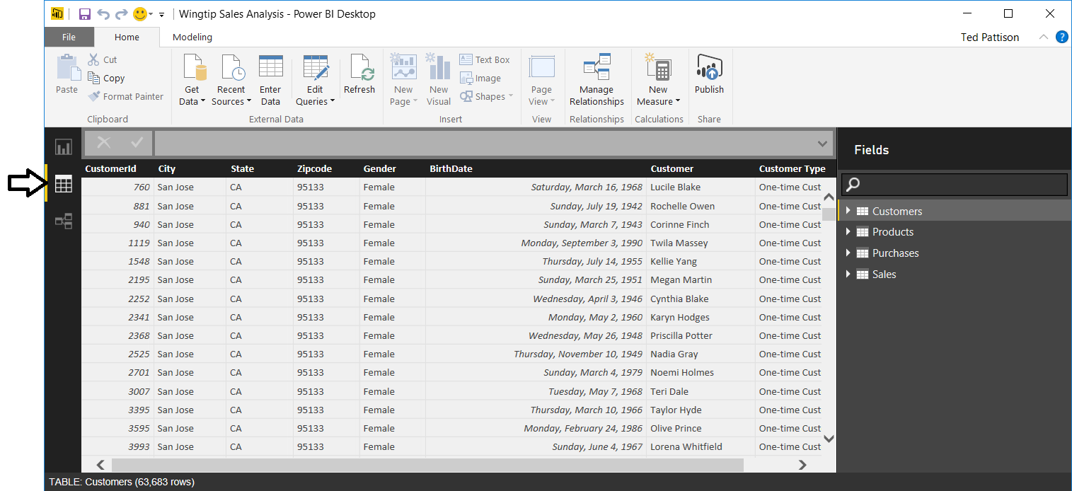

1. Take a moment to review the data in each of the four tables in the data model by clicking on the tables inside the **Fields** list.
2. Click the bottom button in the sidebar to navigate to relationship view. You should see that the four tables are arraigned in a star schema where the **Sales** table has a relationship established with each of the three other tables in the data model

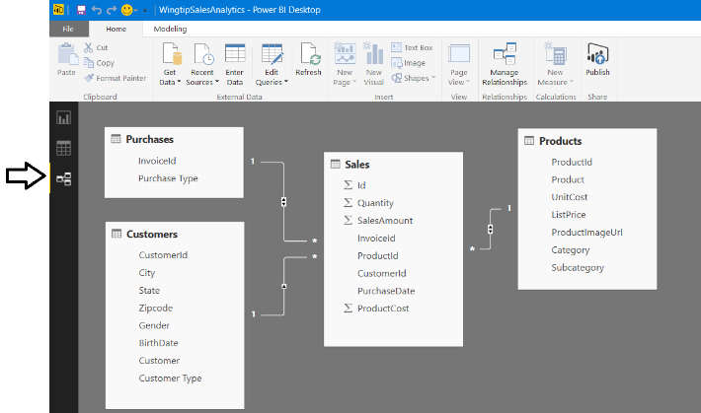

1. Now it's time to inspect the data model from a different perspective. More specifically, you will examine the data model from the perspective of a consumer who is designing reports and creating visuals using the Power BI Desktop report designer.
   1. Click the top button in the sidebar to navigate to report view.

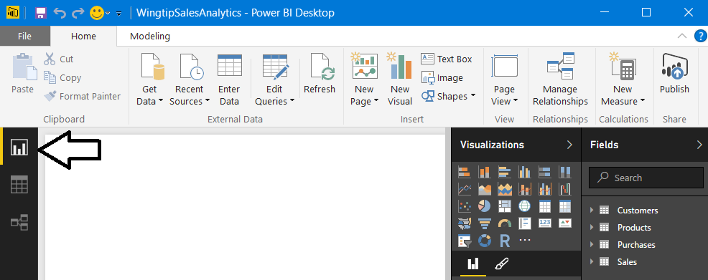

* 1. Inside the **Fields** list, use the mouse to expand the fields inside the **Sales** table. You can see that there are several fields in the **Sales** table that will never be used when designing reports such as the four identifier columns. The data model will be easier for consumers such as report designers to understand if you hide these types of fields which add unnecessary clutter.

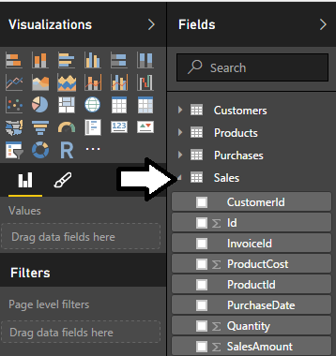

1. Use relationship view to update the data model by hiding fields in the **Sales** table that are unnecessary to display in report view.
   1. Navigate to relationship view in the Power BI Desktop window.
   2. Using the mouse, right-click on the **Id** column in the **Sales** table and select the **Hide in Report View** command.

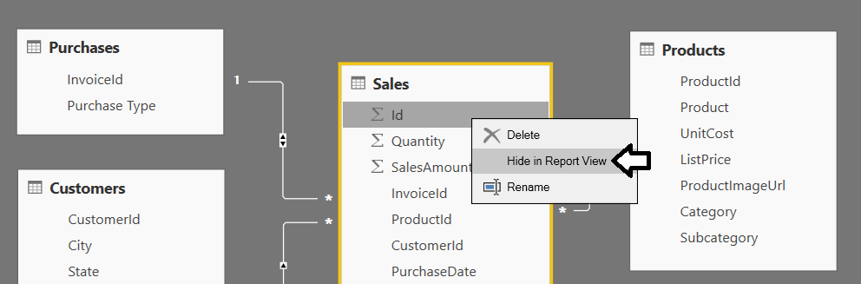

* 1. Right-click on the **InvoiceId** column in the **Sales** table and select the **Hide in Report View** command.
  2. Right-click on the **CustomerId** column in the **Sales** table and select the **Hide in Report View** command.
  3. Right-click on the **ProductId** column in the **Sales** table and select the **Hide in Report View** command.
  4. Now, navigate back to report view and examine the set of fields displayed for the **Sales** table.

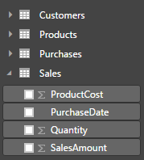

You should be able to see that hiding unnecessary columns from report view makes your data model easier to use. This is especially true in the scenario where you are creating a data model that other less technical people will be using to create reports & dashboards.

1. Modify the formatting of the **BirthDate** column in the **Customers** table.
   1. In the Power BI Desktop windows, navigate back to data view.
   2. In the **Fields** list on the right, select the **Customers** table to display its rows and columns.
   3. Select the **BirthDate** column.
   4. Modify the the **BirthDate** column formatting using the **Format** menu to select a format of **Date Time > 3/14/2001 (M/d/yyyy)**.

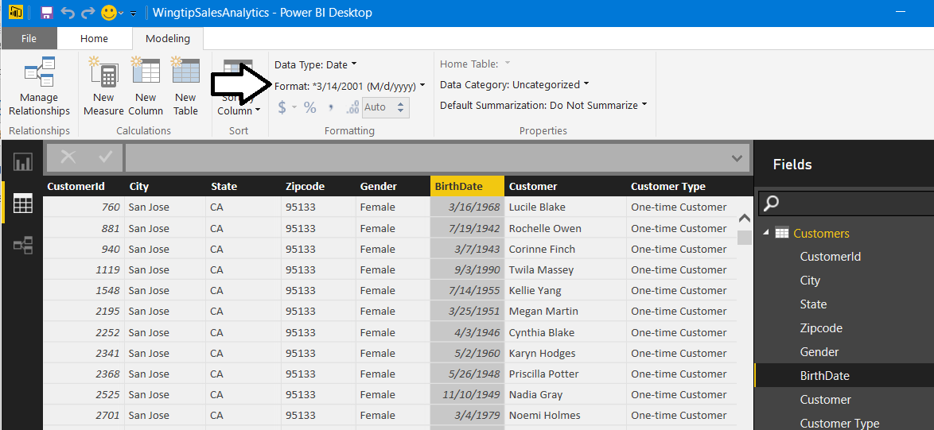

* 1. The **BirthDate** column should now reflect the change in formatting.

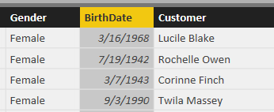

1. Modify the formatting of columns in the **Products** table.
   1. In the **Fields** list on the right, select the **Products** table to display its rows and columns.
   2. Select the **UnitCost** column by clicking on its column header.
   3. Use the **Format** menu button in the ribbon to update the format setting to **Currency > $ English (United States)** and set the number of decimal places to **2** in the spin control located underneath the **Format** dropdown menu.

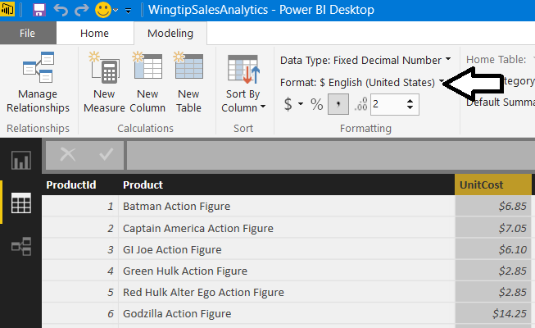

* 1. Changing the format setting of the **ListPrice** column to **$ English (United States)** and set the number of decimal places to **2** so it matches the **UnitCost** column.

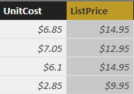

1. Modify the formatting of columns in the **Sales** table.
   1. In the **Fields** list on the right, select the **Sales** table to display its rows and columns.
   2. Select the **Quantity** column by clicking on its column header.
   3. Modify the **Quantity** column byclicking to select the comma button on the ribbon to add a comma separator.

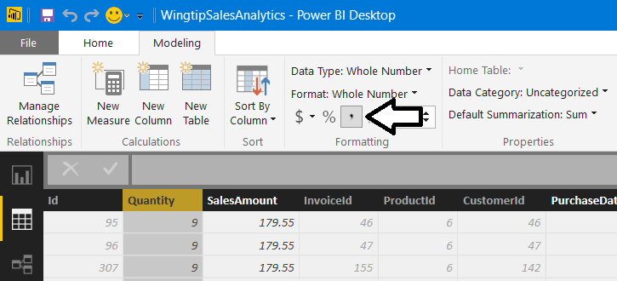

* 1. Select the **SalesAmount** column by clicking on its column header.
  2. Modify the formatting of the **SalesAmount** column to **Currency > $ English (United States)** and set the number of decimal places to **2** in the spin control located underneath the **Format** dropdown menu

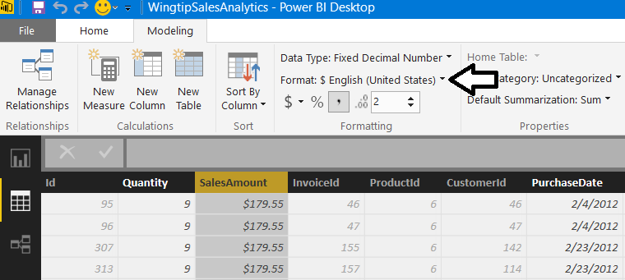

* 1. Select the **PurchaseDate** column by clicking on its column header.
  2. Modify the formatting of the **PurchaseDate** to of **Date Time > 3/14/2001 (M/d/yyyy)**.

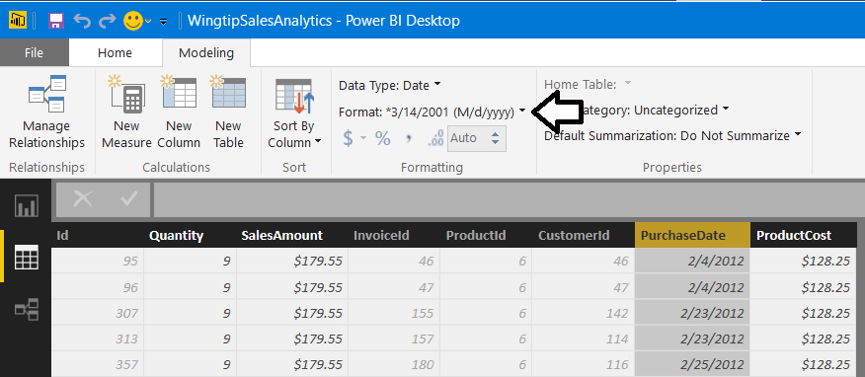

* 1. Select the **ProductCost** column by clicking on its column header.
  2. Modify the formatting of the **ProductCost** column to **Currency> $ English (United States)** and set the number of decimal places to **2** in the spin control located underneath the **Format** dropdown menu.

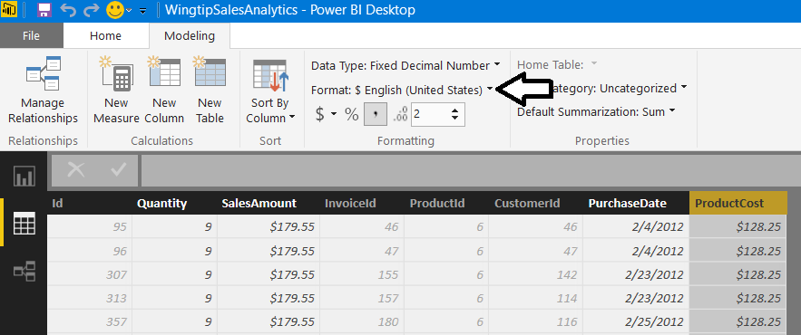

1. See the effect of your formatting by adding a visual to a report.
   1. Navigate to report view. There should be an empty report for the project with a single page named **Page 1**.

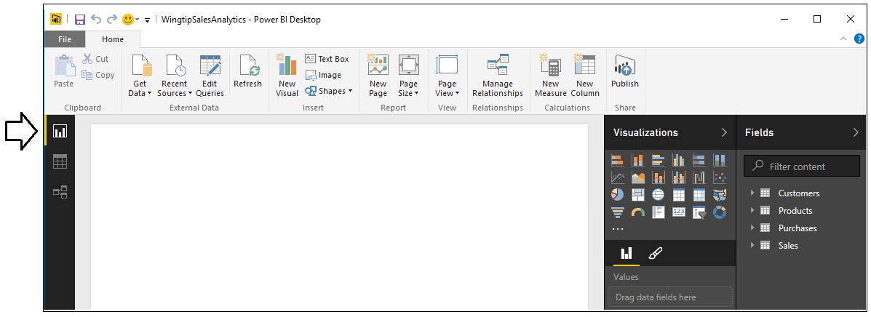

* 1. Change the name of the page in the report from **Page 1** to **Sales by State**.

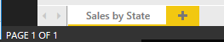

* 1. Create a new visual in the report by selecting the checkbox for the **SalesAmount** column in the **Fields** list.

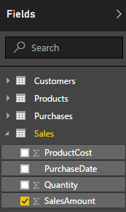

* 1. When you select the **SalesAmount** column, Power BI Desktop will automatically add a new visual to the report based on the visualization type of **Clustered Column Chart**.

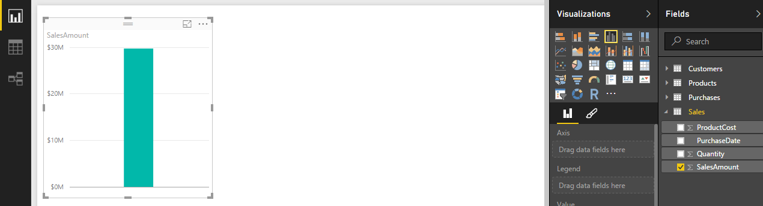

* 1. Click the **Clustered Bar Chart** button in the **Visualizations** list to change the visualization type to a clustered bar chart.

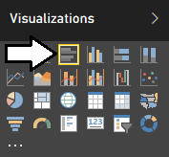

* 1. Since you haven’t added any row labels yet, the clustered bar chart currently displays a single bar showing total sales.

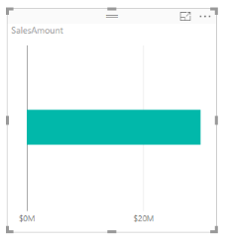

* 1. Drag and drop the **States** field from the **Fields** list into the **Axis** well of the **Visualizations** pane.

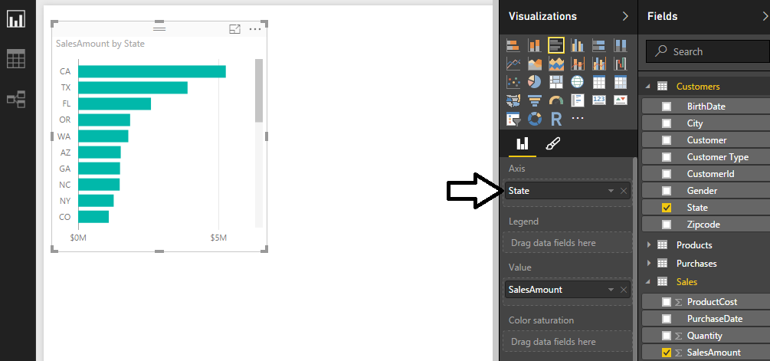

* 1. Use your mouse to resize the visual so that it can display all the stats without a scrollbar.

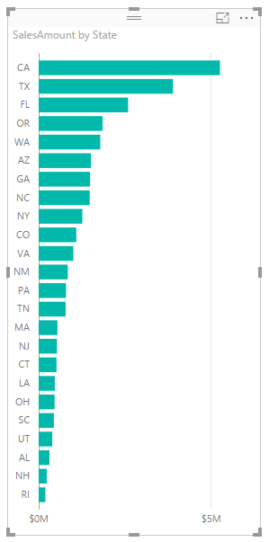

* 1. Reposition the visual to the bottom left corner of the page as shown in the following screenshot.

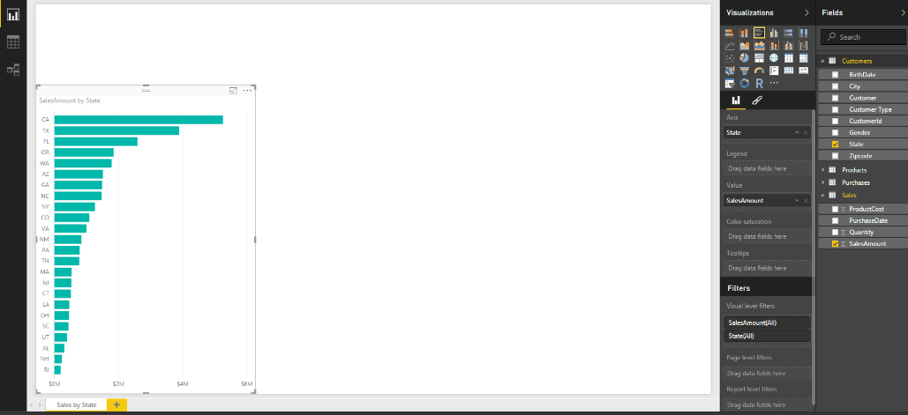

1. Save the work you have done by clicking the Save button in the upper left corner of the Power BI Desktop window.
2. Add a calculated column to the **Sales** table named **SalesProfit** to determine profit by calculating the difference between **SalesAmount** and **ProductCost**.
   1. Navigate to data view.
   2. Select the **Sales** table in the **Fields** list.
   3. Create a new calculated column by clicking the **New Column** button in the ribbon.

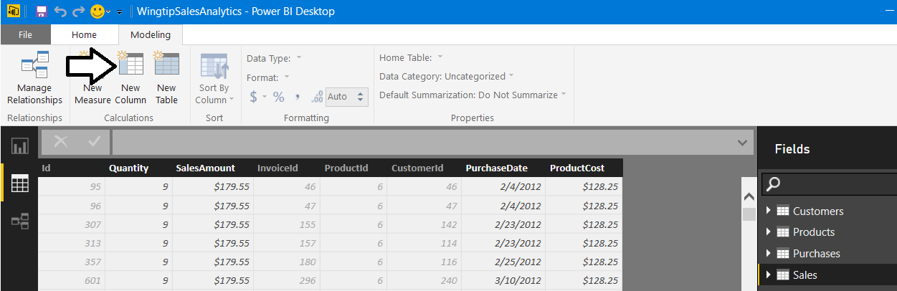

* 1. Enter to following DAX expression into the formula bar to create the calculated column named **SalesProfit**.

SalesProfit = Sales[SalesAmount]-Sales[ProductCost]

* 1. Press the **ENTER** key to add the calculated column to the table. You should be able to see a **SalesProfit** value for each row in the **Sales** table.

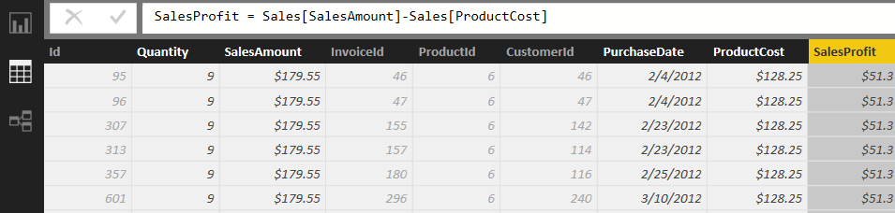

* 1. Configure the column’s formatting by using the **Format** menu on the ribbon to select **Currency > English (United States)**.

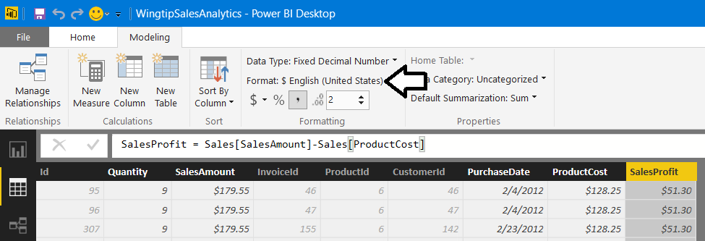

1. Update the clustered bar chart visual you created in the previous exercise.
   1. Navigate to report view.
   2. Select the visual you created in the previous exercise.
   3. Using your mouse, drag and drop the **ProductCost** column from the **Fields** list into the **Value** well in the **Visualizations** pane.
   4. Using your mouse, drag and drop the **SalesProfit** column from the **Fields** list into the **Value** well in the **Visualizations** pane.

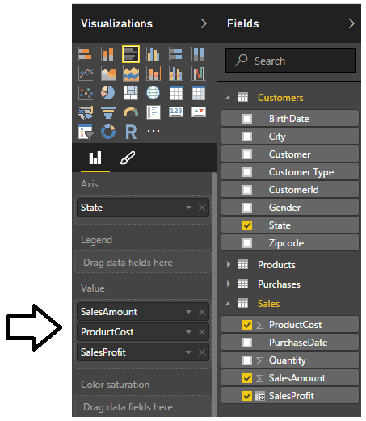

* 1. You should now see that the cluster bar chart is showing additional bars for product cost and profit. Note you might have to resize the visual and make it a little taller to get rid of the scrollbars.

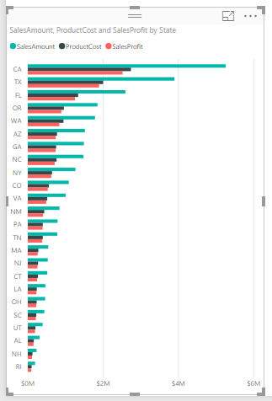

1. Add a calculated column to the **Sales** table named **PurchaseYear** to indicate the calendar year of each purchase.
   1. Navigate to data view.
   2. Select the **Sales** table in the **Fields** list.
   3. Create a new calculated column by clicking the **New Column** button in the ribbon.
   4. Enter to following DAX expression into the formula bar to create the calculated column named **PurchaseYear**.

PurchaseYear = YEAR(Sales[PurchaseDate])

* 1. Press the **ENTER** key to add the calculated column to the table. You should be able to see a calendar year value (e.g. 2012) for each row in the **Sales** table

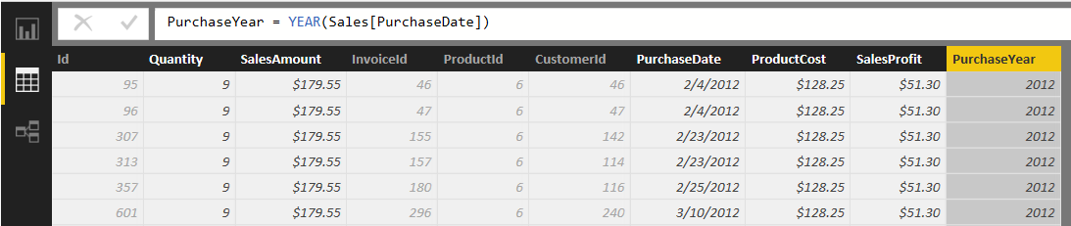

1. Use the new calculated column named **PurchaseYear** in a report
   1. Navigate to report view.
   2. Make sure that no visuals are selected on the page so that you can create a new visual.
   3. Select the checkbox for the **SalesAmount** column in the **Fields** list to create a new visual.
   4. Click the **Matrix** button in the **Visualizations** list to change the visualization type to a matrix.

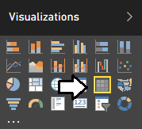

* 1. Add a second field to the visual by dragging the **State** column from the **Customers** table in the **Fields** list into the **Rows** well to displays a separate row for each state.

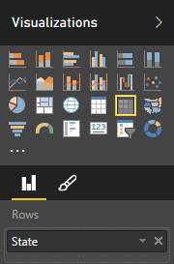

* 1. Now the matrix should display a row for each state that shows the aggregated sum of the **SalesAmount** column.

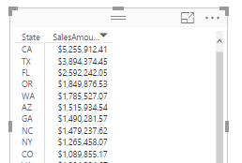

* 1. Use the mouse to reposition the visual so it takes up the bottom right corner of the page as shown in the following screenshot.

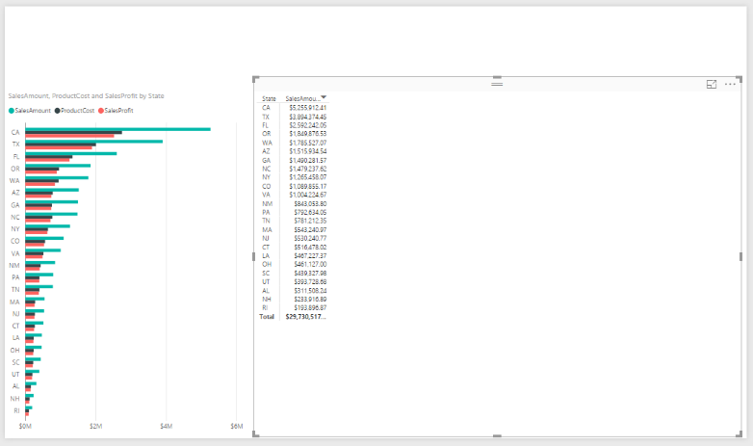

* 1. Increase the font size of the Matrix visual by changing the **Text Size** property to **10pt**. The Text Size property can be found in the Format properties pane inside the **General** section.

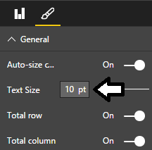

* 1. Extend the matrix visual to pivot on the **PurchaseYear** column. Accomplish this by using the mouse to drag the **PurchaseYear** column from the **Fields** list and drop it into the **Columns** well in the **Visualization** pane

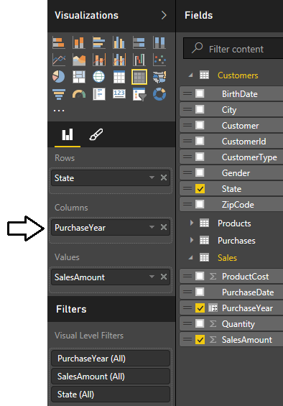

* 1. The visual should now display a column for each year from 2012 through 2015.

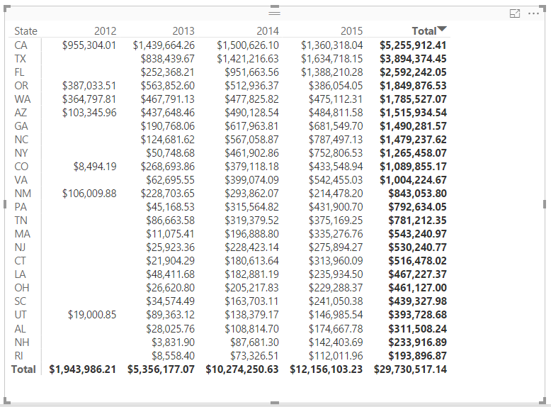

1. Add a calculated column to the **Customers** table named **Age** to indicate the age of the customer.
   1. Navigate to data view.
   2. Select the **Customers** table in the **Fields** list.
   3. Create a new calculated column by clicking the **New Column** button in the ribbon.
   4. Enter the following DAX expression into the formula bar to create the calculated column named **Age**.

Age = Floor( (TODAY()-Customers[BirthDate])/365, 1)

* 1. Press the **ENTER** key to add the calculated column. You should be able to see a whole number for the age of each customer.

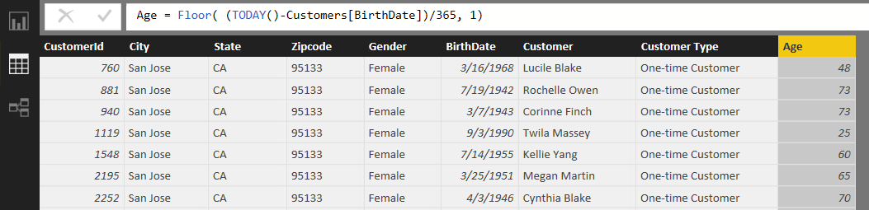

* 1. Use the **Default Summarization** dropdown menu in the ribbon to change the default summarization setting for **Age** column from **Sum** to **Average**.

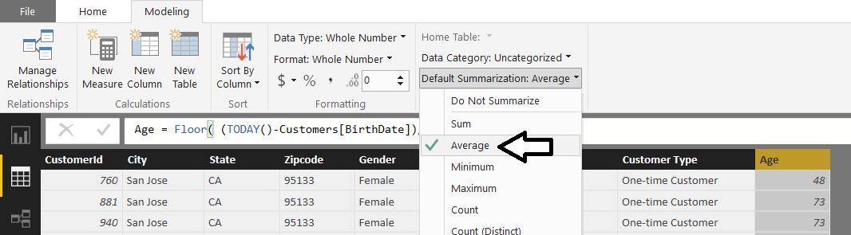

1. Add a calculated column to the **Customers** table named **Age Group** to break customers up into age-based sets.
   1. Create a new calculated column in the **Sales** table by clicking the **New Column** button in the ribbon.
   2. Enter to following DAX expression into the formula bar to create the calculated column named **Age Group**.

Age Group =

SWITCH( TRUE(),

[Age] >= 65, "Ages 65 and over",

[Age] >= 50, "Ages 50 TO 65",

[Age] >= 40, "Ages 40 TO 49",

[Age] >= 30, "Ages 30 TO 39",

[Age] >= 18, "Ages 18 TO 29",

[Age] < 18, "Ages under 18"

)

* 1. After creating the calculated column, you should be able to verify that the **Age Group** column calculates a value for each customer row which places that customer in a bucket for a particular age group.

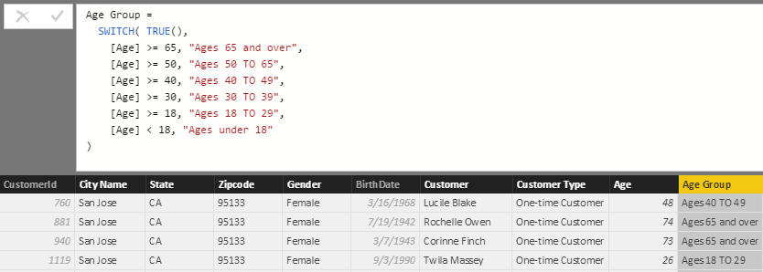

1. Use the **Age Group** calculated column as a row label in a matrix visual.
   1. Navigate to report view.
   2. Make sure that no visuals as selected on the page.
   3. Create a new visual in the report by selecting the checkbox for the **Age Group** column in the **Fields** list.

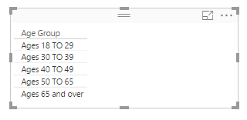

Note that this visual does not display a row for the age demographic value of **Age under 18** even though you added that value to the DAX formula. The reason for this is that the Wingtip Sales database you are working with does not contain any customers under 18 years of age so the age demographic value of **Age under 18** is automatically filtered out of the visual.

* 1. Change the visualization type of the new visual by clicking the **Matrix** button in the **Visualizations** list.
  2. Use the mouse to resize and reposition the visual so it appears on top of the matrix you created earlier.

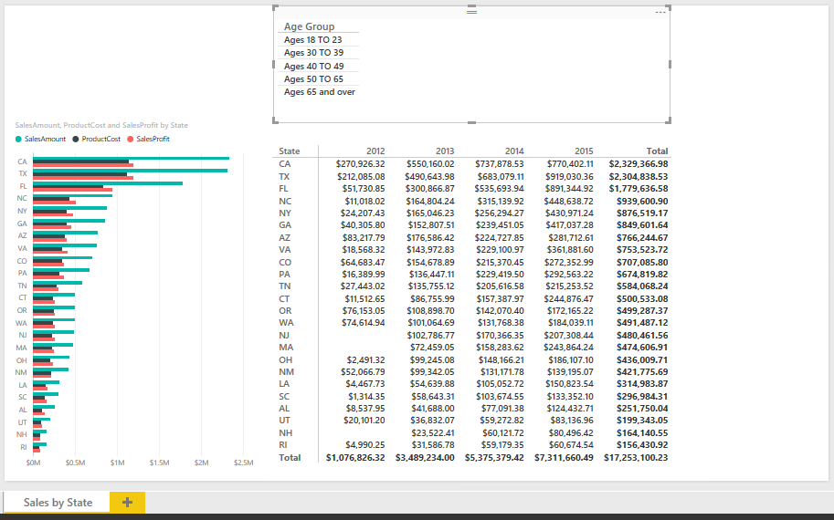

* 1. Now it’s time to modify the table visual by adding a new column to show the count of customers in each age group. Accomplish this by dragging the **CustomerId** column from the **Customers** table in the **Fields** list and dropping it into the **Values** well in the **Visualizations** pane. When you drop the **CustomerId** column into the **Values** well, make sure to drop it so it appears underneath the **Age Group** column.

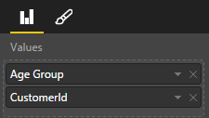

* 1. Click on the dropdown menu of the **CustomerId** field inside the **Values** well so you can see and change the aggregation that will be performed. Select the aggregation type that is **Count (Distinct)**.

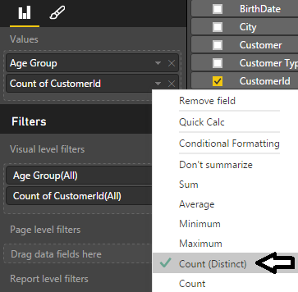

* 1. Now the new visual should display one row per age group which includes a total count of customers.

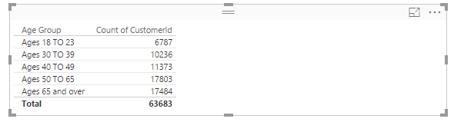

* 1. Click on the column header for the **Count of CustomerId** column to sort the age groups with most customers to the top.

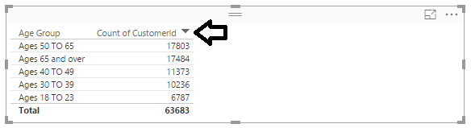

* 1. Drag the **Quantity** column from the **Sales** table and drop it into the **Values** well in the **Visualizations** pane.
  2. Drag the **SalesAmount** column from the **Sales** table and drop it into the **Values** well in the **Visualizations** pane.
  3. Configure the summarization type for the **Quantity** field and the **SalesAmount** field to perform a **Sum**.

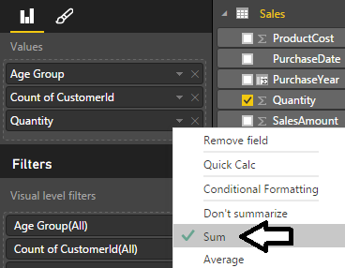

* 1. The visual should now display a new **Quantity** column as well as a **SalesAmount** column displaying aggregated totals.

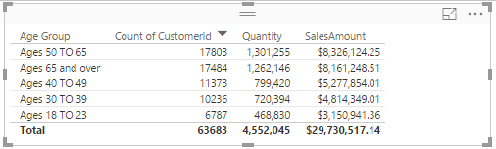

* 1. Sort the rows in the table visual by clicking in the column header for the **SalesAmount** column so that the **Age Group** with the greatest amount of sales revenue is sorted to the top.

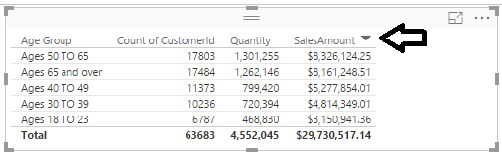

At this point, you might be bothered by the fact that some of the column header names in this visual are not a pretty as they could be. For example, it would be less confusing to business users if the column displaying a count of customers had a column heading of **Customer Count** instead of **Count of CustomerId**. You will address this issue later in the lab exercise where you begin to extend the data model by creating measures.

1. Save the work you have done by clicking the Save button in the upper left corner of the Power BI Desktop window.

### Exercise 3: Extending the Data Model with a Lookup Table

In this exercise, you will extend the data model by adding a new lookup table named **SalesRegions** which assigns a geographic sales region to each state. The work to accomplish this will involve importing data from an Excel workbook to create the **SalesRegions** table and also creating a relationship between the **SalesRegions** table and the **Customers** table. You will also create calculated columns in the **Customers** table to pull in related data from the **SalesRegions** table.

1. Locate the Excel workbook file which contains the **SalesRegions** table.
   1. Using Windows Explorer, open the folder at **c:\Student\Data** and locate the Excel workbook file named **SalesRegions.xlsx**.
   2. Double-click on named **SalesRegions.xlsx**. to open it inside Microsoft Excel 2016.
   3. Once the workbook file opens in Excel, take a moment to examine what’s inside. You should be able to verify that there is a **SalesRegions** table which contains a row for each of the 50 states along with the state full name and an assigned sales region. As you can see from the following screenshot, the 50 states have been divided into three sales regions which are **Western Region**, **Central Region** and **Eastern Region**.

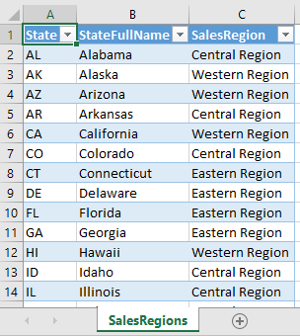

* 1. Close Microsoft Excel and make sure you do not save any chnages to **SalesRegions.xlsx**.

1. Import the **SalesRegions** table into the data model of the current project.
   1. Navigate back to Power BI Desktop.
   2. Click on the **Home** tab on the ribbon.
   3. Drop down the **Get Data** menu in the ribbon and select the **Excel** command to display the **Navigator** dialog.

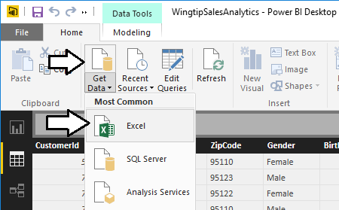

* 1. In the **Navigator** dialog, click the checkbox to select the **SalesRegion** table. Make sure to select the top checkbox for the **SalesRegion** table and not the bottom checkbox for the **Sales Region** worksheet. Once you have selected the **SalesRegion** table, you should be able to see a sample of its rows in the **Navigator** dialog as shown in the following screenshot.

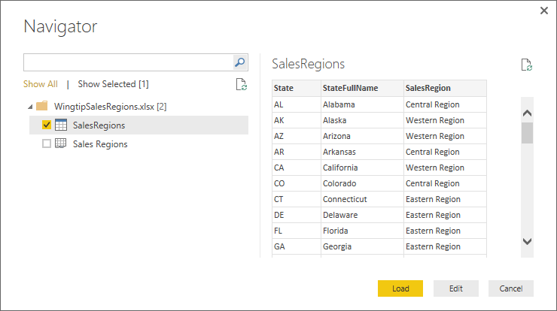

* 1. Click the **Load** button to load the data and to create the **SalesRegions** table. Power BI Desktop will display the **Load** dialog until the import process completed.

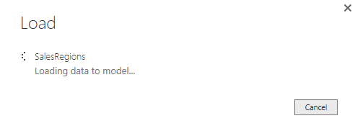

* 1. Once the import process completes, you should be able to see **SalesRegions** table in data view.

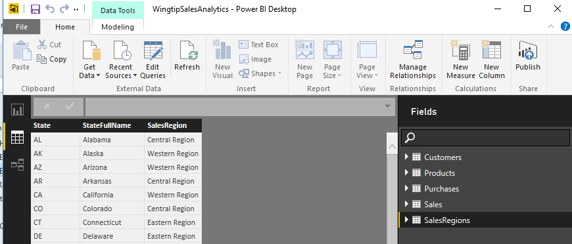

1. Examine the relationship that has been created between the **Customers** table and the **SalesRegions** table.
   1. Navigate to relationship view.
   2. You should be able to see **SalesRegions** table.
   3. Rearrange the table layout to match the following screenshot.

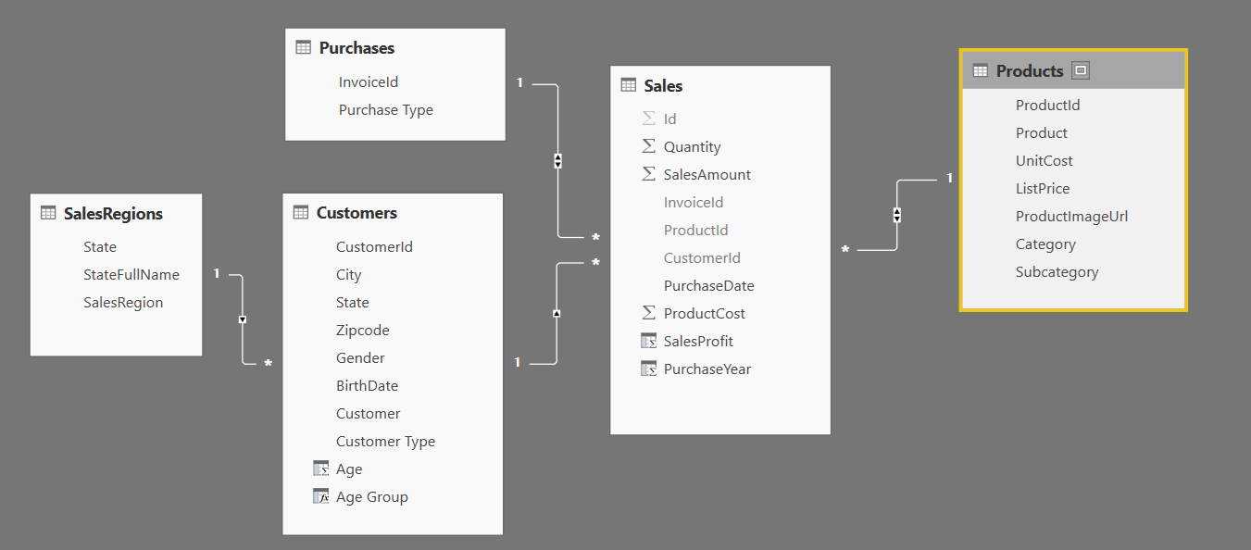

* 1. You should be able to see that a relationship has already been created between the **SalesRegions** table and the **Customers** because both tables contain a similar column named **State**.

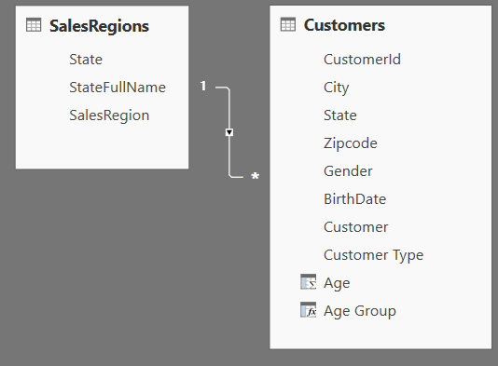

Since there is a relationship between the **SalesRegions** table and the **Customers** table, you can begin to use the **RELATED** function provided by DAX. More specifically, you can use the **RELATED** function to create calculated columns in the **Customers** table that are written to pull in data from the **SalesRegions** table.

1. Add a calculated column to the **Customers** table named **Sales Region** to display the sales region for each state.
   1. Navigate to data view.
   2. Select the **Customers** table in the **Fields** list.
   3. Create a new calculated column by clicking the **New Column** button in the ribbon.
   4. Enter to following DAX expression into the formula bar to create the calculated column named **Sales Region**.

Sales Region = RELATED(SalesRegions[SalesRegion])

* 1. Press the **ENTER** key to add the calculated column to the table. You should be able to see a value in the **Sales Region** column for each row in the **Customers** table.

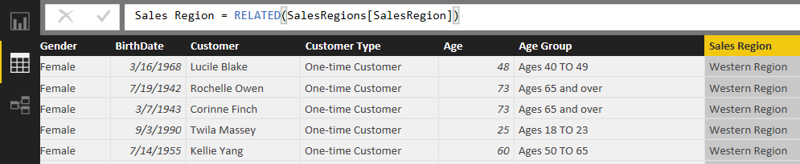

1. Add a calculated column to the **Customers** table named **State Name** to display the full state name.
   1. Create a new calculated column in the **Customers** table by clicking the **New Column** button in the ribbon.
   2. Enter to following DAX expression into the formula bar to create the calculated column named **State Name**.

State Name = RELATED(SalesRegions[StateFullName])

* 1. Press the **ENTER** key to add the calculated column to the table. You should be able to see a value in the **Sales Region** column for each row in the **Customers** table.

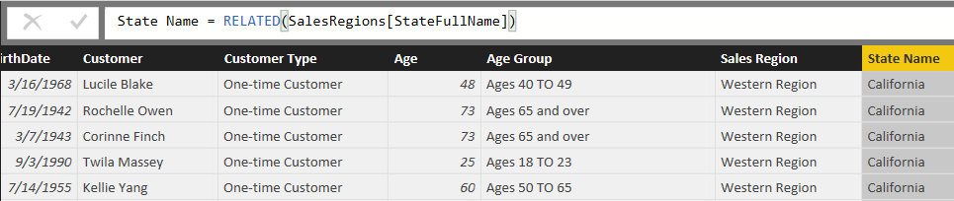

Now that you have pulled all the important data from the **SalesRegions** table into the **Customers** table, there is no need to display the **SalesRegions** table in report view. In the next step, you will hide the **SaleRegions** table to simplify view of the data model that is shown in report view.

1. Hide the **SalesRegions** table from report view.
   1. Navigate to relationship view.
   2. Right-click on the the **SalesRegions** table

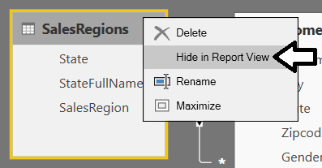

* 1. Navigate to report view and verify that the **SalesRegions** table is not displayed as one of the tables in the **Fields** list.

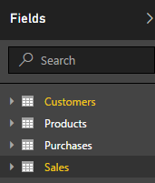

1. Update the matrix with row labels based on the **State** column to use the **State Name** column instead.
   1. Navigate back to report view.
   2. Select the matrix visual with the row labels based on the **State** column.
   3. Remove the **State** field from the **Rows** well in the **Visualization** pane and replace it with the **State Name** column. The visual should now show the full state name instead of the two-character state abbreviation.

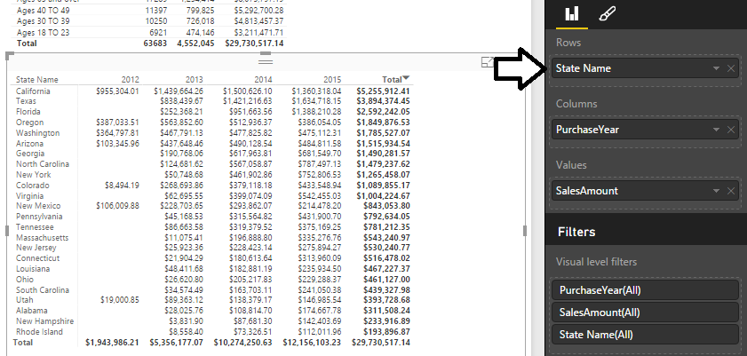

1. Add a slicer visual to the report to filter all displayed results by sales region.
   1. Navigate to report view if you are not already there.
   2. Make sure that no visuals are selected on the page so that you can create a new visual.
   3. Select the checkbox for the **Sales Region** column in the **Fields** list to create a new visual.
   4. Click the **Slicer** button in the **Visualizations** list to change the visual type to a slicer.

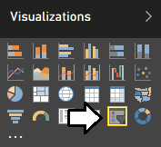

* 1. Using the mouse, reposition the slicer visual so it appears in the upper, left-hand corner of the page as shown in the following screenshot.

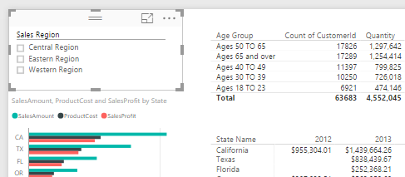

* 1. Change the alignment of the slicer visual from vertical to horizontal. Accomplishing this by first clicking the Edit Pen button in the **Visualization** pane to view the appearance properties of the visual and then by modifying the **Orientation** property to a value of **Horizontal**. Also enable the **Select All** property by setting its value to **On**.

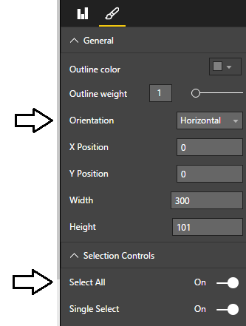

* 1. The slicer visual should now appear with a horizontal layout with an additional **Select All** node.

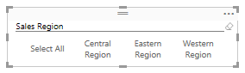

* 1. Click on the different nodes of the slicer visual to see its filtering effect. If you click on the **Eastern Region** node, all the other visuals apply a filter to only shows states assigned to the Eastern sales region.

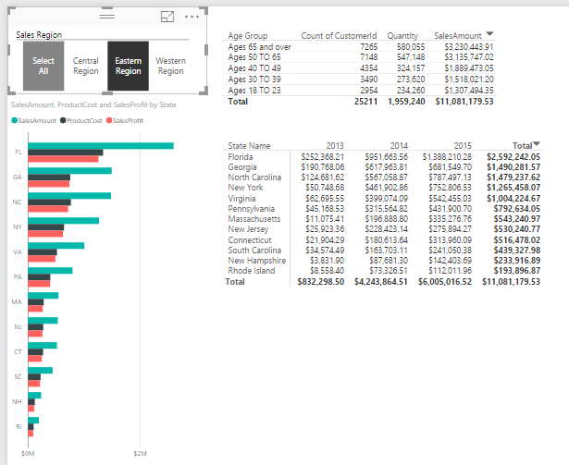

1. Save the work you have done by clicking the Save button in the upper left corner of the Power BI Desktop window.

### Exercise 4: Extending the Data Model by Creating Measures

In this exercise you will create four measures named **Units Sold, Sales Revenue, Product Cost** and **Profit** that will perform sum aggregations on the **Sales** table. You will also create a measure named **Customer Count** that performs a distinct count aggregation on the **Customers** table. As you will see, creating measures to use in your report visuals will give you much greater control over the column names, formatting and aggregations that are displayed in your reports.

1. Create a measure named **Units Sold** to perform a sum aggregation on the **Quantity** column of the **Sales** table.
   1. Navigate to data view.
   2. Select the **Sales** table from the **Fields** list.
   3. Create a new measure by clicking the **New Measure** button in the ribbon.

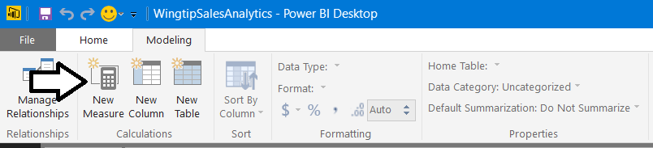

* 1. Enter to following DAX expression into the formula bar to create the measure named **Units Sold**.

Units Sold = SUM(Sales[Quantity])

* 1. Press the **ENTER** key to add the measure to data model.
  2. Modify the formatting by clicking and selecting the Comma button on the ribbon to add a comma separator.

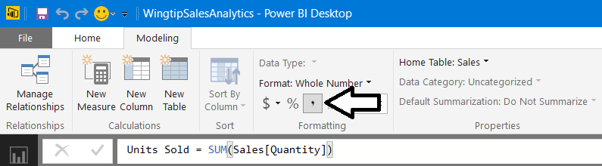

1. Create a measure named **Sales Revenue** to perform a sum aggregation on the **SalesAmount** column of the **Sales** table.
   1. Create a new measure by clicking the **New Measure** button in the ribbon.
   2. Enter to following DAX expression into the formula bar to create the measure named **Sales Revenue**.

Sales Revenue = Sum(Sales[SalesAmount])

* 1. Press the **ENTER** key to add the measure to data model.
  2. Modify the formatting by dropping down the **Format** menu on the ribbon and selecting **Currency > $ English (United States)**. Also use the spinner control below the **Format** menu to set the number of decimal places shown to zero.

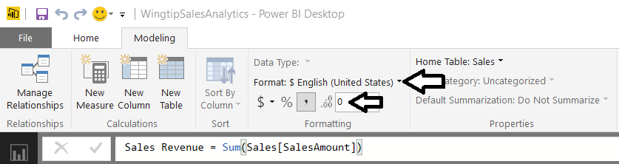

1. Create a measure named **Product Cost** to perform a sum aggregation on the **ProductCost** column of the **Sales** table.
   1. Create a new measure by clicking the **New Measure** button in the ribbon.
   2. Enter to following DAX expression into the formula bar to create the measure named **Product Cost**.

Product Cost = Sum(Sales[ProductCost])

* 1. Press the **ENTER** key to add the measure to data model.
  2. Modify the formatting by dropping down the **Format** menu on the ribbon and selecting **Currency > English (United States)**. Also use the spinner control below the **Format** menu to set the number of decimal places shown to zero.

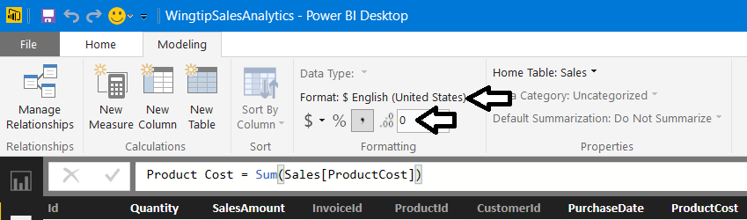

1. Create a measure named **Profit** to perform a sum aggregation on the **SalesProfit** column of the **Sales** table.
   1. Create a new measure by clicking the **New Measure** button in the ribbon.
   2. Enter to following DAX expression into the formula bar to create the measure named **Profit**.

Profit = SUM(Sales[SalesProfit])

* 1. Press the **ENTER** key to add the measure to data model.
  2. Modify the formatting by dropping down the **Format** menu on the ribbon and selecting **Currency > English (United States)**. Also use the spinner control below the **Format** menu to set the number of decimal places shown to zero.

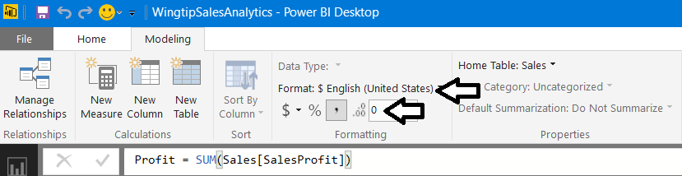

1. Create a measure named **Customer Count** to perform an aggregation to count the number of rows inthe **Customers** table.
   1. Make sure the **Customers** table is selected.
   2. Create a new measure by clicking the **New Measure** button in the ribbon.
   3. Enter the following DAX expression into the formula bar to create the measure named **Customer Count**.

Customer Count = COUNTROWS(Customers)

* 1. Press the **ENTER** key to add the measure to data model.
  2. Modify the formatting by clicking and selecting the Comma button on the ribbon to add a comma separator.

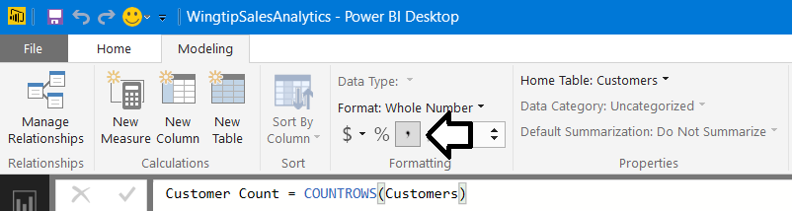

1. Update the visuals in the report to use the new measures you have just created.
   1. Navigate to report view.
   2. Select the clustered bar chart visual.

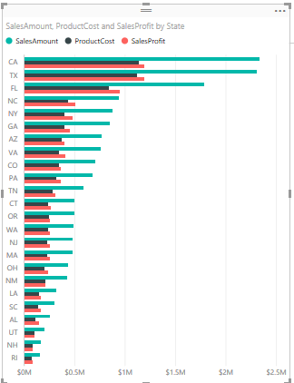

* 1. Examine the properties of this visual in the **Visualizations** pane. The **Value** well should currently contain the three fields named **SalesAmount**, **ProductCost** and **SalesProfit**.

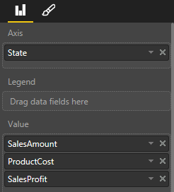

* 1. Remove those three fields from the **Value** well and replace them with the new measures named **Sales Revenue**, **Product Cost** and **Profit**.

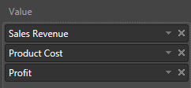

* 1. You will notice that the sort order of this visual is now based on the **State** field because you removed the **SalesAmount** field that was being used for sorting. Resort the rows in the visual using **Sales Revenue**.

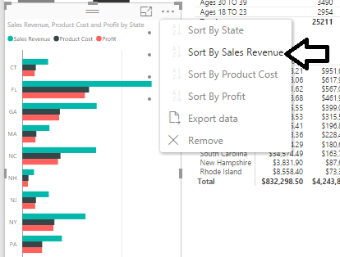

* 1. Now this visual looks more polished because it is using measures instead of aggregated columns to produce its values.

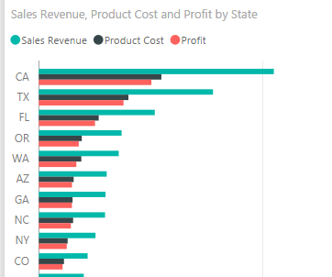

* 1. Select the matrix visual which displays sales revenue by state and year.
  2. In the **Visualizations** pane, remove the **SalesAmount** column from the **Values** well and replace it with **Sales Revenue** measure.

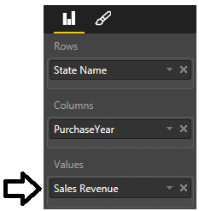

* 1. The matrix visual should display its numbers with currency formatting with no decimal places.
  2. Click the **Total** column header to sort the state rows by total sales revenue.

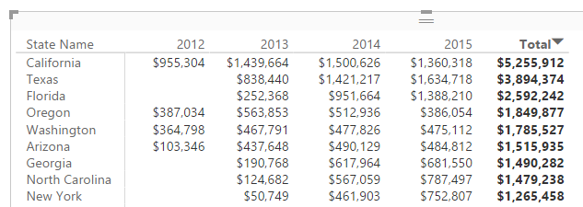

* 1. Select the matrix visual which displays a row for each age group.
  2. Notice how some of the columns contain text (e.g. **Count of CustomerId**) that is not very user-friendly.

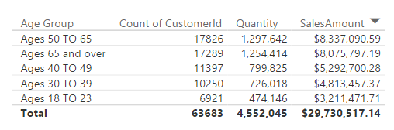

* 1. Examine the properties of this visual in the **Visualizations** pane. The **Value** well should currently contain the three fields named **Count of CustomerId**, **Quantity** and **SalesAmount**.

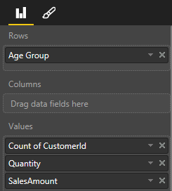

* 1. Remove those three fields from the **Value** well and replace them with the new measures named **Customer Count**, **Units Sold** and **Sales Revenue**.

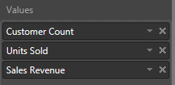

* 1. The columns of the table visual are now more user-friendly and the formatting of values looks better as well.

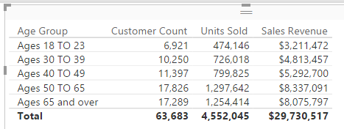

* 1. Click on the **Sales Revenue** column header to sort the age groups by sales revenue.

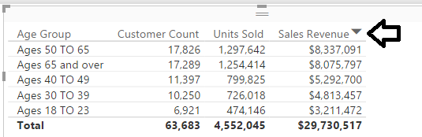

1. You will complete your work in this exercise by cleaning up the data model by hiding fields in report view.
   1. Navigate to Relationship View so you can see all the tables in the project’s data model.
   2. Resize each table so that is properly displays all its fields.

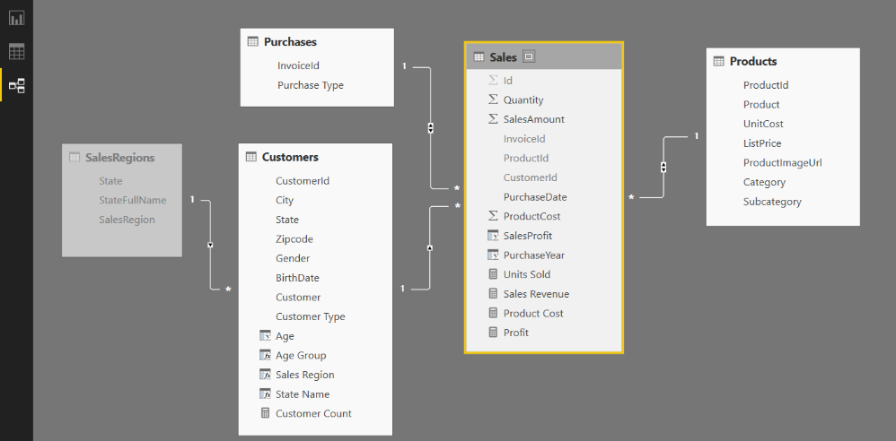

* 1. In the **Purchases** table, hide the **InvoiceId** column by right-clicking the column and selecting **Hide in Report View**.

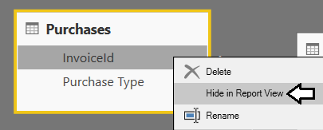

* 1. Use the same technique to hide the **CustomerId** field and the **BirthDate** field from the **Customers** table.

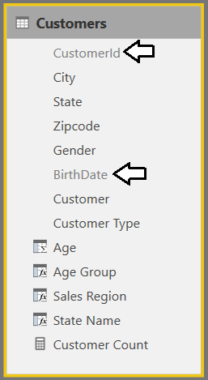

* 1. Use the same technique to hide the **ProductId** field, the **UnitCost**, field and the **ListPrice** field from the **Products** table.

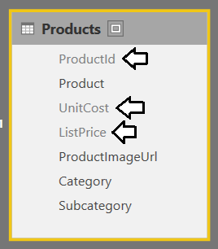

* 1. In the **Sales** table, hide every field except for the 4 measures named **Units Sold**, **Sales Revenue**, **Product Cost** and **Profit**.

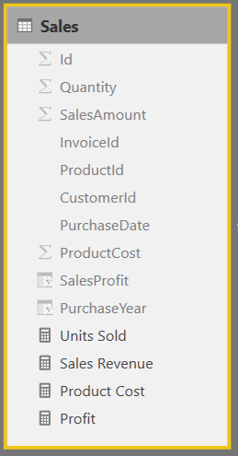

When you hide all the fields in a table except for its measures, Power BI Desktop begins to treat this table as a **fact table**. The main effect this has in Power BI Desktop is that the table will be displayed above in the Fields list when in report view. However, Power BI Desktop has an unfortunate bug where it will not recognize a table as a fact table until you close and reopen the project. In the next step, you will close Power BI Desktop. Then you will restart Power BI Desktop and reopen the current project. This will allow you to see how Power BI Desktop displays measure-only tables in Report View.

1. Save the current project by clicking the **Save** button in the ribbon.
2. Close and restart Power BI Desktop to see the effects of a measure-only table.
   1. Close Power BI Desktop.
   2. Restart Power BI Desktop
   3. Reopen the Power BI Desktop project file named **c:\Student\Projects\Wingtip Sales Analysis.pbix**.
3. Examine the tables of the project's data model in Report View.
   1. Navigate to Report view.

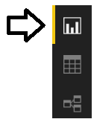

* 1. Examine the tables shown in **Fields** list on the right side of the Power BI Desktop application window. You can see that the **Sales** table is displayed first with a calculator icon. The three other tables shown below are displayed with a standard table icon.

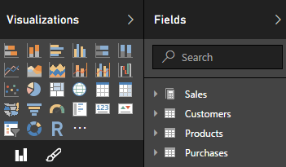

You have to agree that these changes to the data model make it easier to use when in report view.

### Exercise 5: Extending the Data Model with Geolocation Metadata

In this exercise you will begin by adding explicit support to sort sales regions so that the Western Region is first followed by Central Region and then the Eastern Region. After that, you will configure geolocation metadata to fields in the **Customers** table including **State**, **City** and **Zipcode**. After that, you will create a new report page with a map visual to visualize how customer sales data is spread out across various geographic regions within the United States.

1. Create a new query to named **SalesRegionsSort** which returns data to sort by sales regions in a custom sort order.
   1. Navigate to the **Home** tab in the ribbon.
   2. Click the **Enter Data** button.

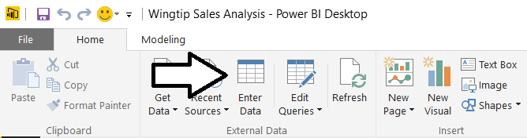

* 1. In the **Create Table** dialog, add two columns named **SalesRegion** and **SalesRegionSortOrder**.
  2. Add a row with a **SalesRegion** value of **Western Region** and a **SalesRegionSortOrder** value of **1**.
  3. Add a row with a **SalesRegion** value of **Central Region** and a **SalesRegionSortOrder** value of **2**.
  4. Add a row with a **SalesRegion** value of **Eastern Region** and a **SalesRegionSortOrder** value of **3**.
  5. Give the new table of name **SalesRegionSort** and then click **Edit** to open the Query Editor window.

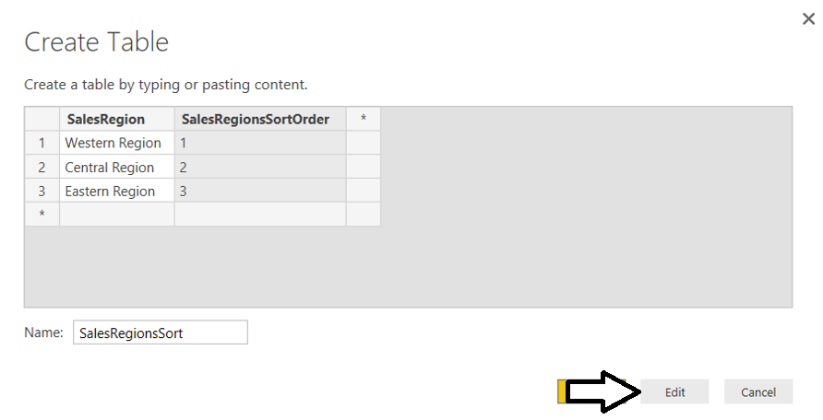

* 1. You should now see the **SalesRegionSort** table in the Query Editor window.
  2. In the left navigation, right click on the **SalesRegionsSort** table and then select **EnableLoad** to disable loading the query result into the project’s data model.

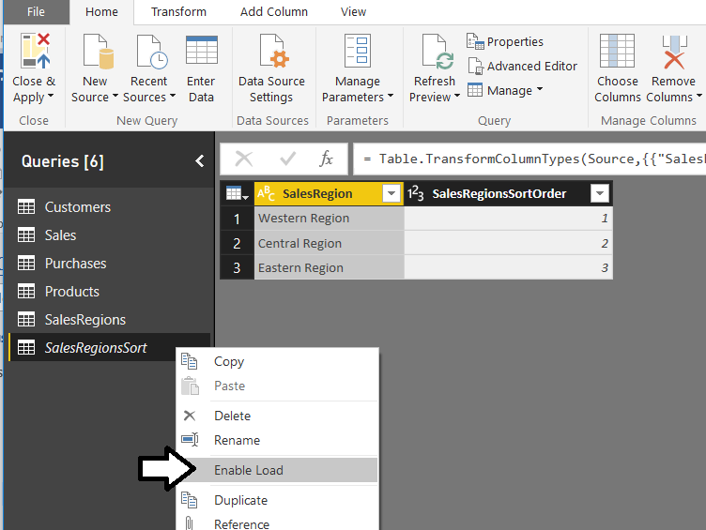

1. Merge the **SalesRegions** query with the **SalesRegionSort** query to add the **SalesRegionSortOrder** column.
   1. Select the **SalesRegion** table in the left navigation of the Query Editor window.
   2. Navigate to the **Home** tab in the ribbon.
   3. Click the **Merge Query** button in the top right corner of the ribbon to open the **Merge** dialog.

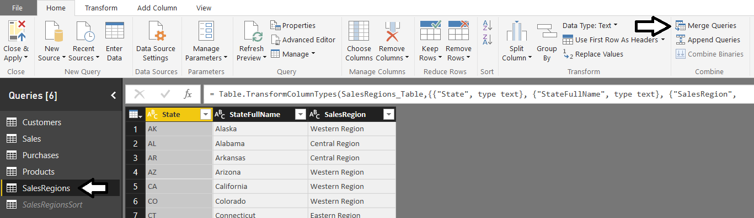

* 1. In the **Merge** dialog, select **SalesRegionSort** from the dropdown menu.
  2. Select the **SalesRegion** column for both the **SalesRegions** query results and the **SalesRegionsSort** query results.
  3. Click **OK**.to complete the merge operation.

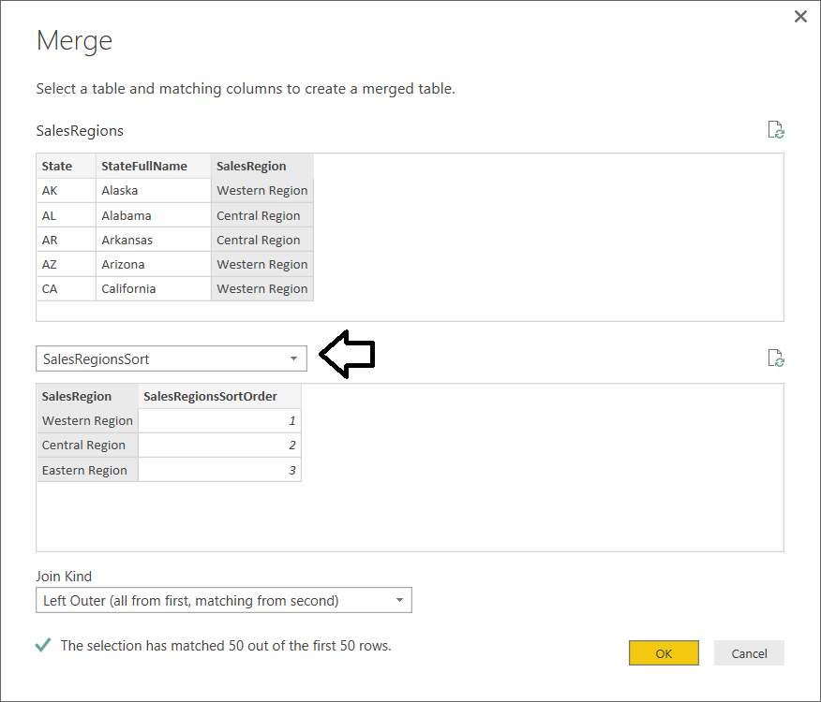

Now you should see a new column named **NewColumn** in the results of the **SalesRegion** query.

* 1. Click the button on the right side of the column header for the **NewColumn** column.

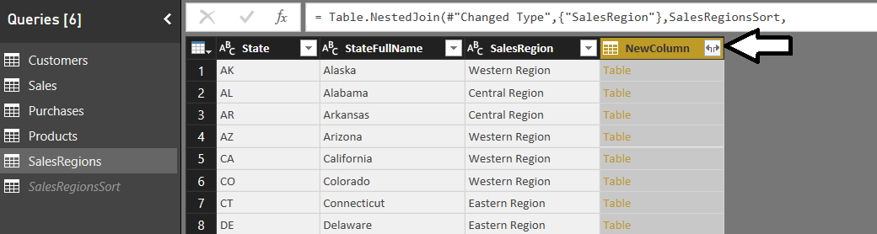

* 1. In the next dialog, select the **Expand** option.
  2. Select only the one column named **SalesRegionSortOrder**.
  3. Uncheck the checkbox with the caption **Use original column name as prefix**.
  4. Click **OK** to complete the expand operation.

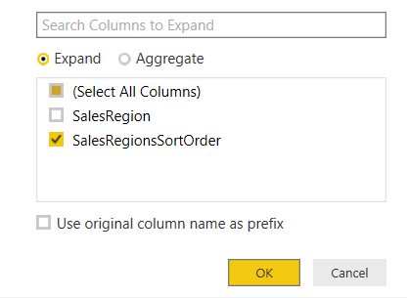

* 1. You should be able to verify that the results of the **SalesRegions** query now contain the **SalesRegionSortOrder** column.

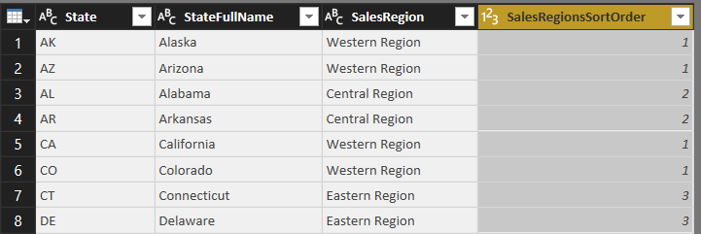

* 1. Click the **Close and Apply** button to execute the **SalesRegions** query which will update the data in the project’s data model.

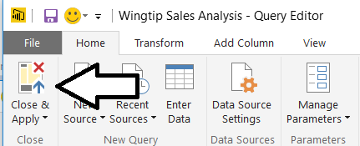

1. Add the **SalesRegionSortOrder** column to the **Customers** table as a calculated field.
   1. Navigate to Data view mode in the Power BI Desktop application window.
   2. Select the **Customers** table in the **Fields** list.
   3. Click the **New Column** button in the ribbon to create a new calculate column.

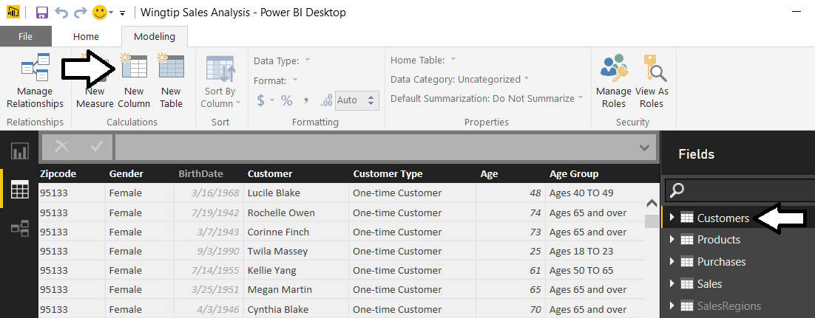

* 1. Type in the following DAX expression to create a new calculated column named **SalesRegionSort**.

SalesRegionSort = RELATED(SalesRegions[SalesRegionsSortOrder])

1. Configure a custom sort column for the **Sales Region** field.
   1. Select the **Sales Region** field from the **Fields** list.
   2. Drop by the **Sort By Column** menu in the ribbon and select the **SalesRegionSort** column.

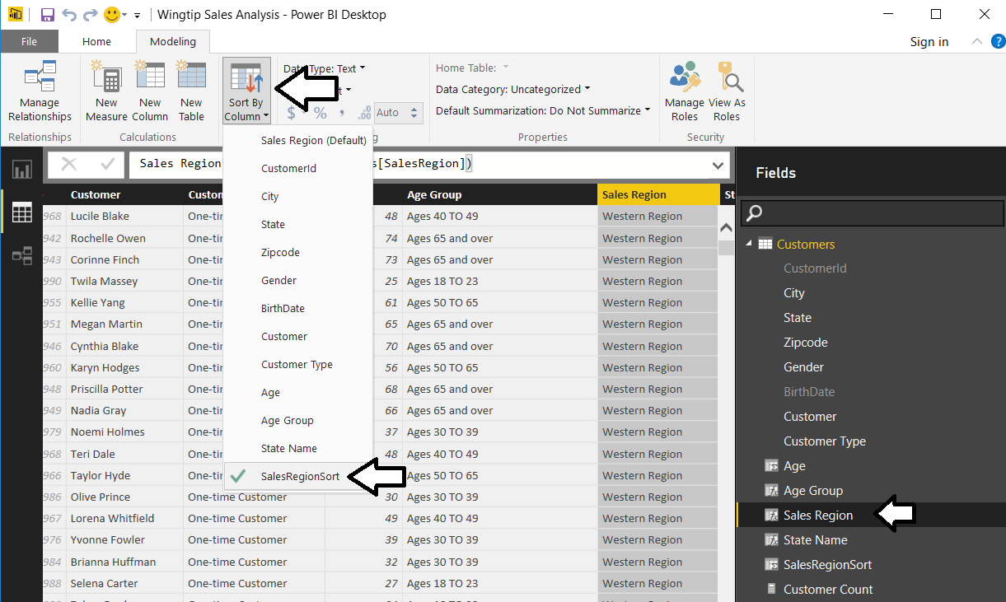

1. In the **Fields** list, right click the **SalesRegionSort** column and select **Hide in Report View**.

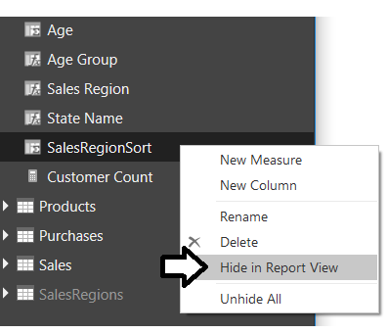

1. Return to Report View and examine the slicer which shows the sales regions. They should now be sorted in a custom sort order with **Western Sales** first followed by **Central Region** and then **Eastern Region**.

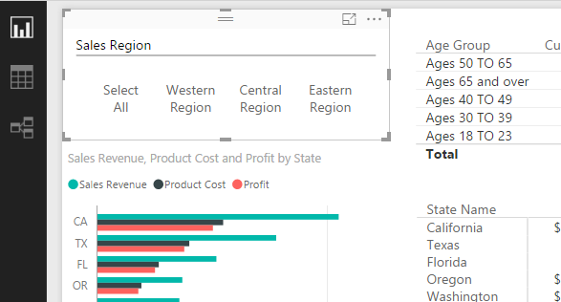

1. Configure Geolocation Metadata for the **State** field in the **Customers** table.
   1. Return to Data View.
   2. From the **Fields** list on the right, select the **State** field from the **Customers** table.
   3. Drop down the **Data Category** menu from the ribbon and select **State or Province**.

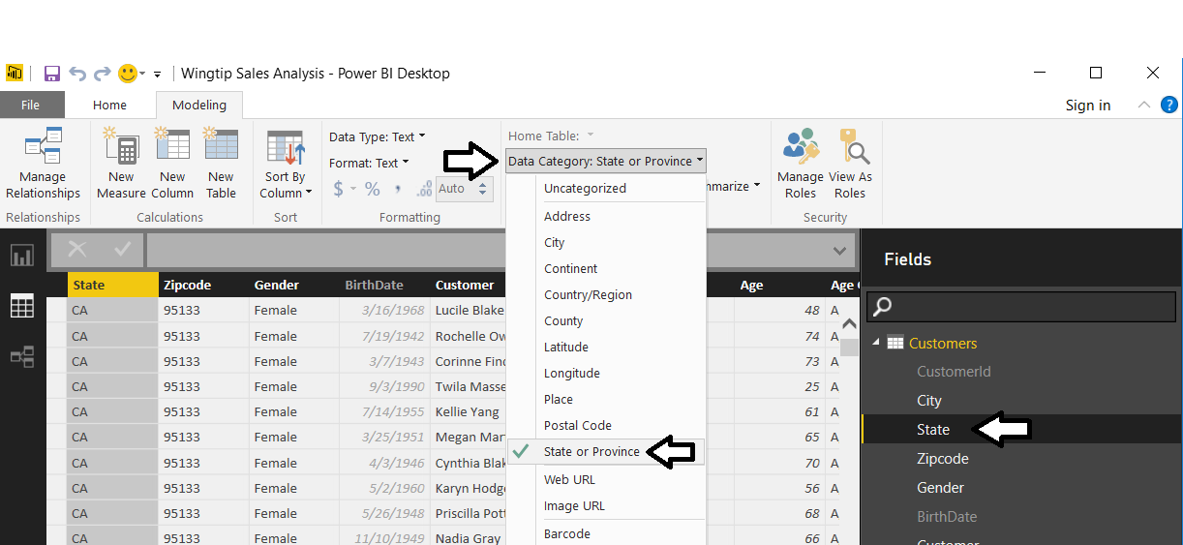

1. Modify the **City** column to contain the state as well as the city to remove ambiguity when determining geographic locations.
   1. Select the **Customers** table in the **Fields** list.
   2. Right-click on the column header for the **City** column and select the **Rename** command.

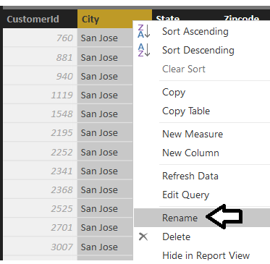

* 1. Rename the column to **City Name**.

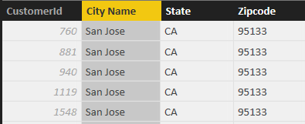

* 1. Navigate to the **Modeling** tab in the ribbon.
  2. Click the **New Column** tab to create a new calculated column.

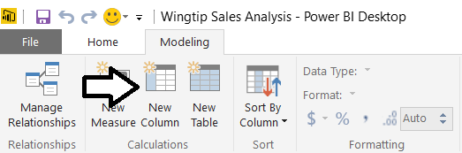

* 1. Add in the following DAX expression to create a new column named **City**.

City = [City Name] & ", " & [State]

* 1. The **City** column should display the city and the state which will remove ambiguity when used as a geolocation field.

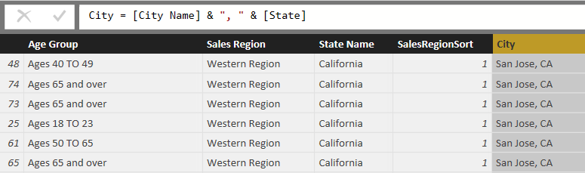

1. Configure geolocation metadata for the **City** field in the **Customers** table.
   1. Return to Data View.
   2. From the **Fields** list on the right, select the **City** field from the **Customers** table.
   3. Drop down the **Data Category** menu from the ribbon and select **City**.

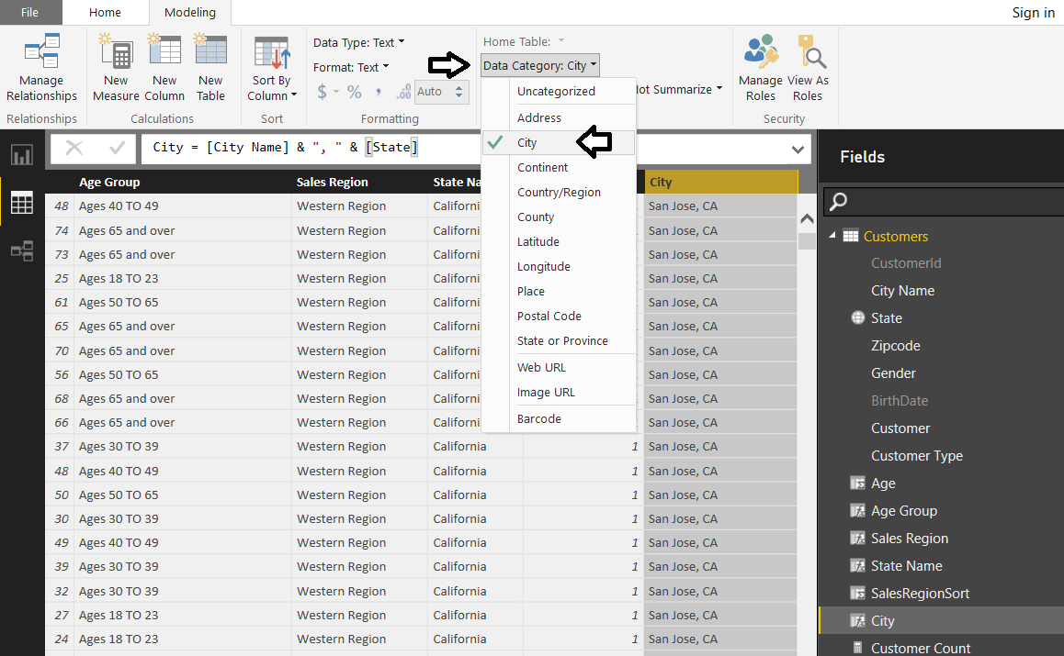

1. Configure geolocation metadata for the **Zipcode** field in the **Customers** table.
   1. Return to Data View.
   2. From the **Fields** list on the right, select the **Zipcode** field from the **Customers** table.
   3. Drop down the **Data Category** menu from the ribbon and select **Postal Code**.

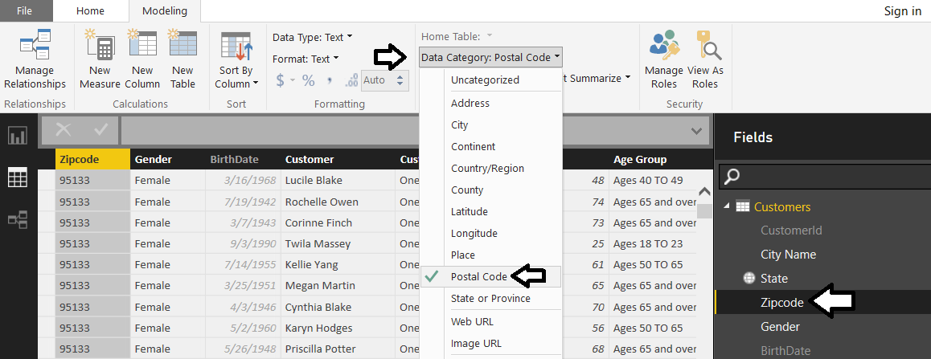

Now that you have configured fields in the **Customers** table with geolocation metadata, it’s time to put this metadata to use by creating a new report page with a map visual to visualize how sales revenue is distributed over geographic regions.

1. Create a new report page.
   1. Return to Report View.
   2. Click on the (**+**) button on the page navigation tab to create a new page.
   3. Rename the new page to **Sales by Geography**.

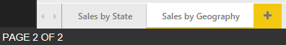

1. Add a background **Rectangle** shape to the report for formatting purposes.
   1. Navigate to the **Home** tab in the ribbon.
   2. Drop down the Shapes menu in the ribbon and select Rectangle to add a new rectangle shape to the report.

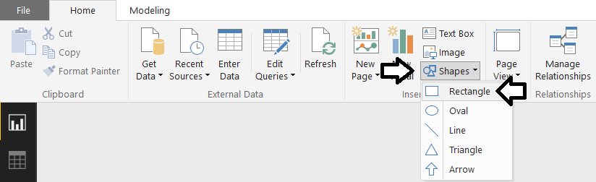

* 1. Using the mouse, reposition the rectangle shape so it takes up the full height of the report page and about 20% of the width as shown in the following screenshot.

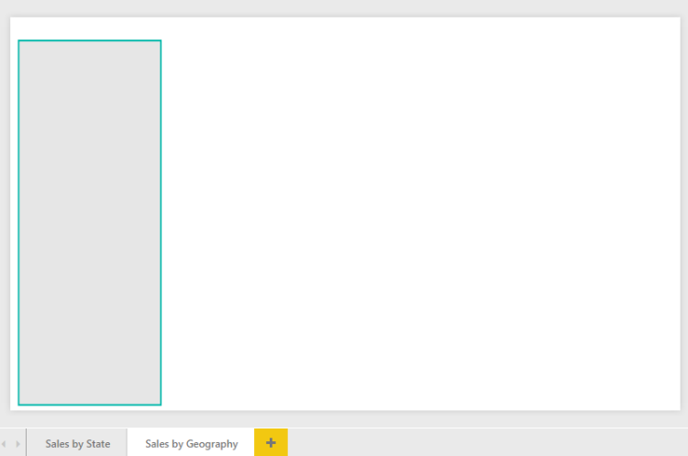

1. Create a new slicer visual to filter by sales region.
   1. Click the **Slicer** button in the **Visualizations** list to add a new slicer visual to the report.

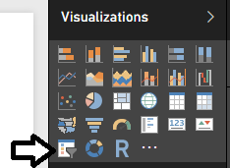

* 1. Add the **Sales Region** field from the **Customers** table into the **Field** well for the slicer.
  2. Reposition the slicer so it sits on top of the rectangle shape as shown in the following screenshot.

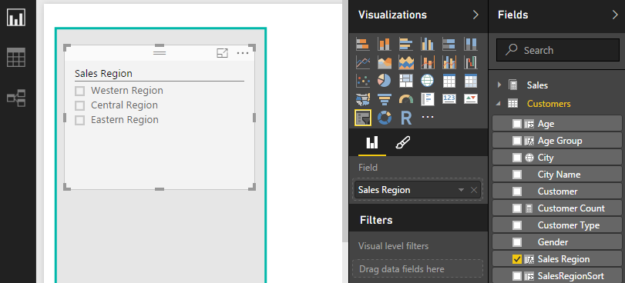

* 1. With the slicer selected, navigate to the **Selection Controls** sections in the **Format** properties pane and set **Select All** to **On**.

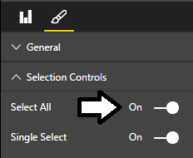

1. Add a new Map visual to display sales revenue by state.
   1. Click the New Visual button on the ribbon to create a new visual.
   2. Click the **Map** button in the **Visualizations** list to change the visual into a Map visual.

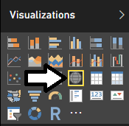

* 1. Configure the fields for the **Map** visual by adding the **State** field from the **Customers** table into the **Location** well and the **Sales Revenue** field from the **Sales** table into the **Size** well.

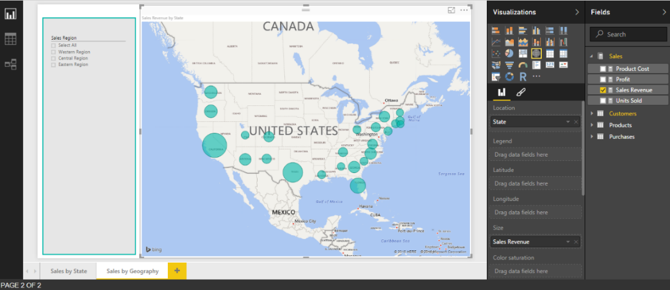

* 1. Add the **Units Sold** field from the **Sales** table and the **Customer Count** field from the **Customers** table into the **Tooltips** well.

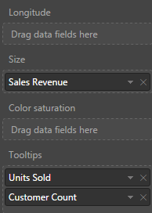

* 1. With the Map visual selected, navigate to the **Data Colors** section in the **Format** properties pane and change the default color to a dark red to it stands out more clearly on the map visual.

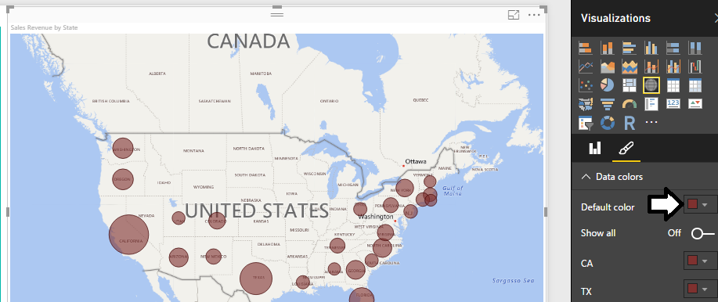

* 1. Test out the **Tooltips** setting by hovering the mouse over a red dot for a specific state. You should see that the **Tooltips** setting displays **State**, **Sales Revenue**, **Units Sold** and **Customer Count**.

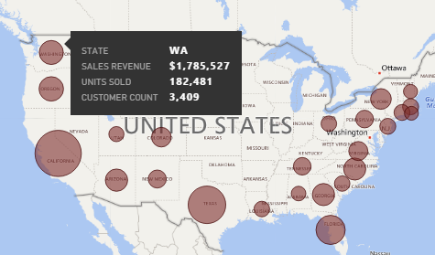

* 1. Try out the slicer. You should be able to select a single sales region and see the map update to reflect the new filtering.

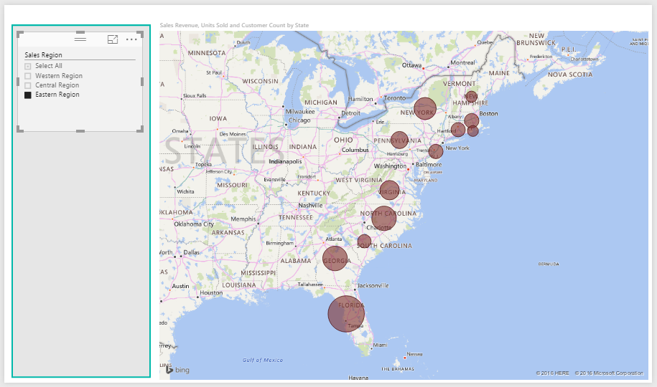

* 1. With the **Map** visual select, navigate to the **Field** properties pane. Remove the **State** field from the **Location** well and replace it with the **City** field from the **Customers** table. Now the red dots are more granular because they represent cities not states.

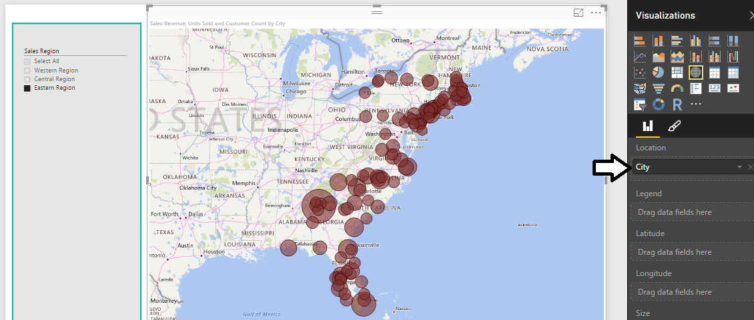

1. Add a second slicer below the first slicer to filter by **State**.
   1. Click the **New Visual** button on the ribbon to create a new visual.
   2. Click the **Slicer** button in the **Visualizations** list to change the visual into a slicer visual.
   3. Configure the new slicer by adding the **State Name** field from the **Customers** table into the **Field** well.

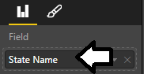

* 1. Reposition the new slicer to it appears just below the first slicer as shown in the following screenshot.

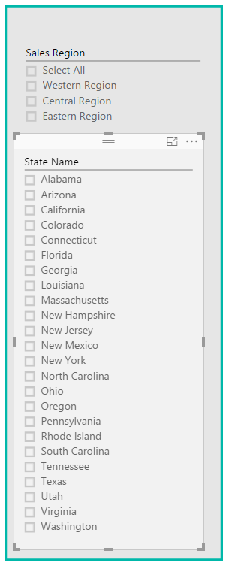

In the next step you will configure the edit interactions between the two slicer visuals. In particular, you do not want the button slider to place a filter on the top slicer.

* 1. Make sure the bottom slicer is selected.
  2. Navigate to the **Format** tab in the ribbon.
  3. Click the **Edit Interactions** button in the ribbon to enter edit interaction mode.
  4. In the **Sales Region** slicer, click the circle icon with the line through it to prevent the other slicer from affecting this slicer.

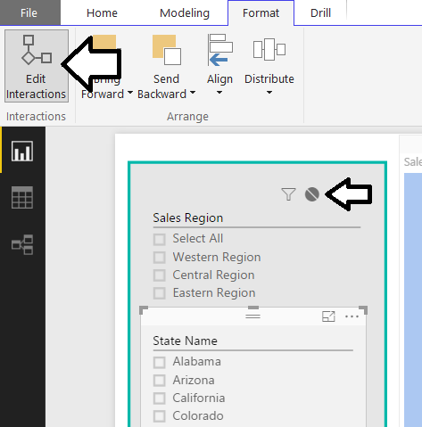

* 1. Test out the finished report page. You should be able to select a sales region from the top slicer which filters the set of states available in the bottom slicer. You should then be able to select a state and see its cities in the Map visual.

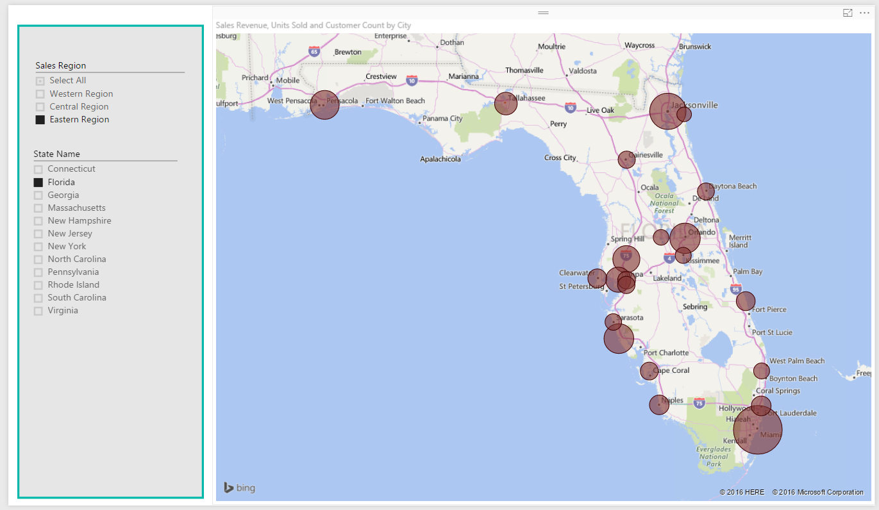

### Exercise 6: Create Dimensional Hierarchies for Products and Customers

In this exercise you will modify the **Products** table to add a new dimension hierarchy named **Product Category**. After that you will create a new report page and a few supporting measures to calculate percentages that each product category, subcategory and product contribute to overall sales revenue. After that, you will modify the **Customers** table by adding a new dimension hierarchy named **Customer Geography**.

1. Navigate to Report view and inspect the tables in the **Fields** list on the right hand side of the Power BI Desktop window.

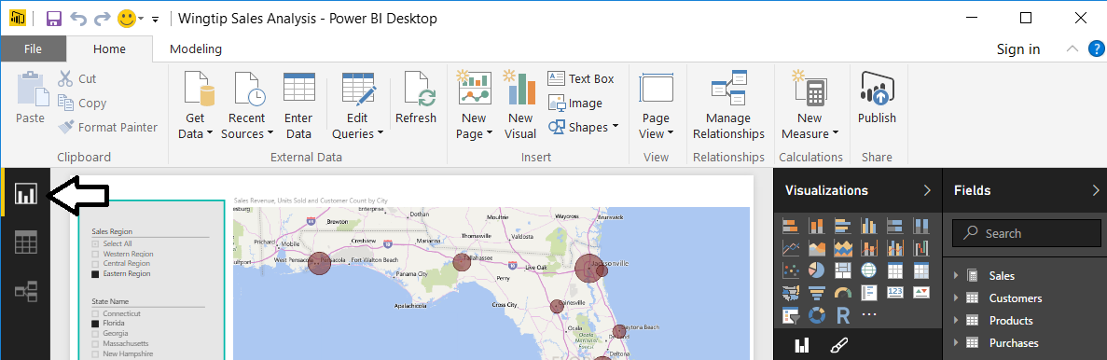

1. Add a new dimensional hierarchy to the **Products** table.
   1. Inspect the **Products** table in the fields list. It should appear as the one shown in the following screenshot.

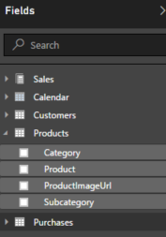

* 1. Right-click on the **Category** field and then select the **New Hierarchy** menu command.

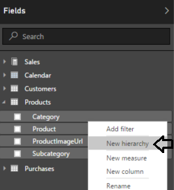

* 1. You should now see a new dimensional hierarchy in the fields list named **Category Hierarchy**.

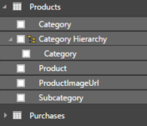

* 1. Right-click **Category Hierarchy** and select the **Rename** menu command.

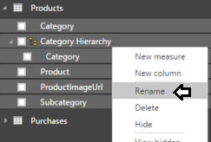

* 1. Rename the new hierarchy **Product Category**.

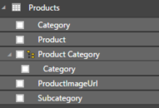

* 1. Right-click on the **Subcategory** field and select the **Add to Product Category** menu command.

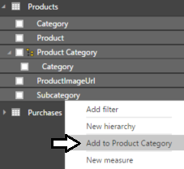

* 1. Right-click on the **Product** field and select the **Add to Product Category** menu command.
  2. The **Product Category** hierarchy should now contain three fields as shown in the following screenshot.

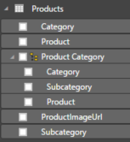

1. Create a new report page and rename it to **Product Revenue Breakdown**.

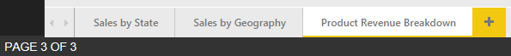

1. Create a new matrix visual to display sales revenue broken out by product category, subcategory and product.
   1. Click the **New Visual** button on the ribbon to add a new visual to the page.
   2. Change the visual to a matrix by clicking the **Matrix** button in the **Visualizations** list.
   3. In the **Fields** list, click the checkbox for the **Product Category**.
   4. Drag and drop the **Sales Revenue** field from the **Sales** table into the **Values** well.

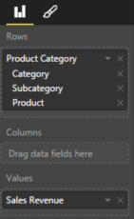

* 1. The Matrix visual should now display sales revenue for each product along with totals for each subcategory and category.

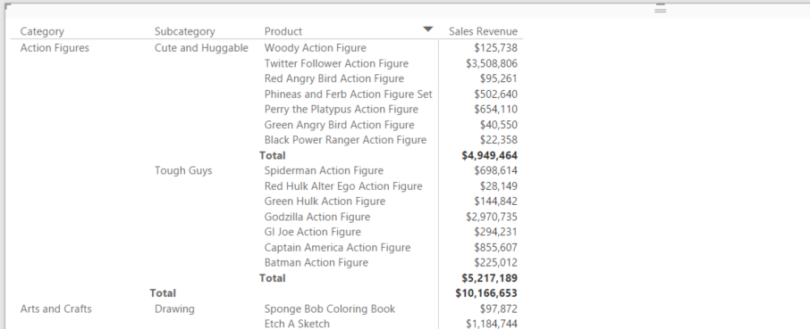

* 1. Reposition the visual so it takes up the height and the width of the entire report page. You need extra width for this visual because you will be adding more columns to it later in this exercise.

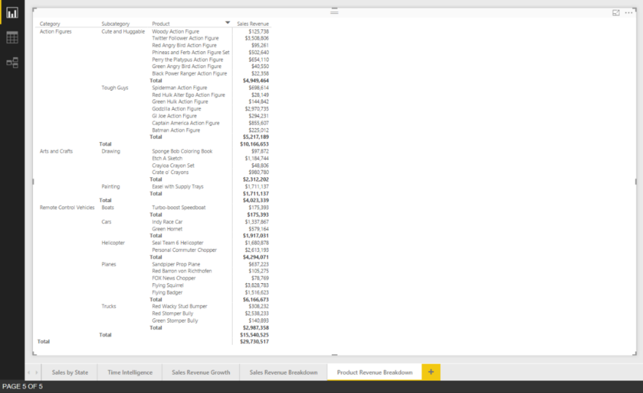

1. Create the **Pct of All Products** measure that calculates the percentage of sales revenue compared to that of all sales revenue.
   1. Navigate to data view.
   2. Select the **Products** table from the **Fields** list.
   3. Create a new measure by clicking the **New Measure** button in the ribbon.

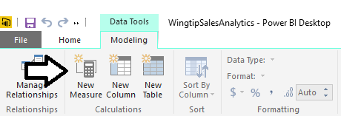

* 1. Enter to following DAX expression into the formula bar to create the measure named **Pct of All Products**.

Pct of All Products =

DIVIDE(

SUM( Sales[SalesAmount] ),

CALCULATE(

Sum ( Sales[SalesAmount] ),

ALL( Products[Category], Products[Subcategory], Products[Product] )

)  
)

* 1. Press the **ENTER** key to add the measure to the data model.
  2. Modify the formatting by dropping down the **Format** menu on the ribbon and selecting **Percentage**. Also use the spinner control below the **Format** menu to set the number of decimal places shown to **2**.

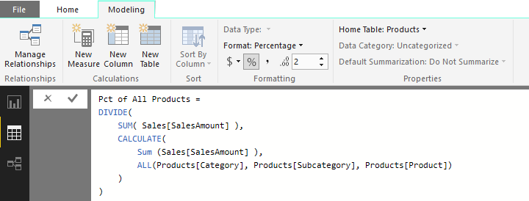

1. Create the **Pct of Product Category** measure that calculates the percentage of sales revenue within the current product category.
   1. Select the **Products** table from the **Fields** list.
   2. Create a new measure by clicking the **New Measure** button in the ribbon.
   3. Enter to following DAX expression into the formula bar to create the measure named **Pct of Product Category**.

Pct of Product Category =

DIVIDE(

SUM( Sales[SalesAmount] ),

CALCULATE(

Sum ( Sales[SalesAmount] ),

ALL( Products[Subcategory], Products[Product] )

)

)

* 1. Press the **ENTER** key to add the measure to the data model.
  2. Modify the formatting by dropping down the **Format** menu on the ribbon and selecting **Percentage**. Also use the spinner control below the **Format** menu to set the number of decimal places shown to **2**.

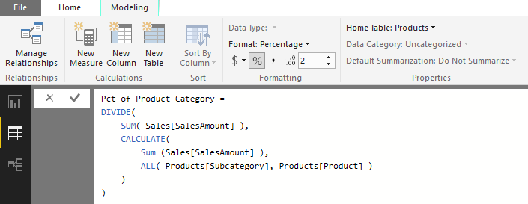

1. Create the **Pct of Product Subcategory** measure that calculates the percentage of sales revenue within the current subcategory.
   1. Select the **Products** table from the **Fields** list.
   2. Create a new measure by clicking the **New Measure** button in the ribbon.
   3. Enter to following DAX expression into the formula bar to create the measure named **Pct of Product Subcategory**.

Pct of Product Subcategory =

DIVIDE(

SUM( Sales[SalesAmount] ),

CALCULATE(

Sum ( Sales[SalesAmount] ),

ALL( Products[Product] )

)

)

* 1. Press the **ENTER** key to add the measure to the data model.
  2. Modify the formatting by dropping down the **Format** menu on the ribbon and selecting **Percentage**. Also use the spinner control below the **Format** menu to set the number of decimal places shown to **2**.

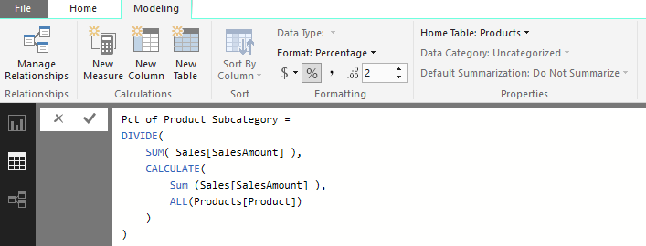

1. Modify the matrix visual on the **Sales Revenue Breakdown** report page to include the three new measures.
   1. Click the report icon on the top of the sidebar to enter Report view mode.
   2. Make sure that the active report page is the **Sales Revenue Breakdown** report page.
   3. Select the matrix visual that you created earlier in this exercise.
   4. Drag and drop the **Pct of All Products** measure from the **Products** table into the **Values** well.
   5. Drag and drop the **Pct of Product Category** measure from the **Products** table into the **Values** well.
   6. Drag and drop the **Pct of Product Subcategory** measure from the **Products** table into the **Values** well.

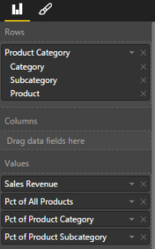

* 1. Your visual should now match the one shown in the following screenshot. If you examine the values of the **Pct of Product Subcategory** measure, you should see that the products in a subcategory have percentages that sum to 100% for that subcategory. If you examine the values of the **Pct of Product Category** measure, you should see that the products in a category have percentages that sum to 100% for that category.

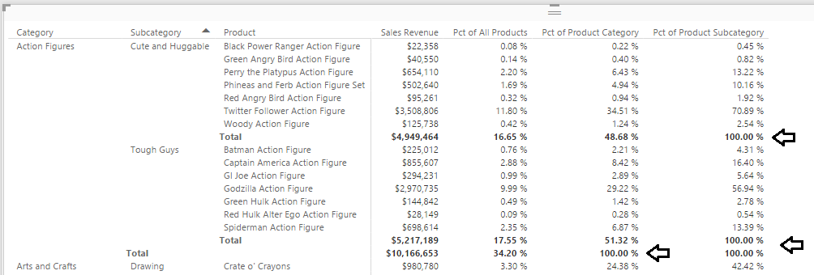

1. Add a new dimensional hierarchy to the **Customers** table.
   1. If you are not already in Report view, use the left navigation to switch to Report view.
   2. Inspect the **Customers** table in the fields list. It should appear as the one shown in the following screenshot.

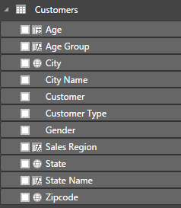

* 1. Right-click on the **Sales Region** field and then select the **New Hierarchy** menu command.

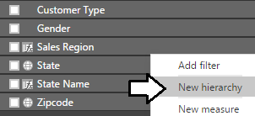

* 1. You should now see a new dimensional hierarchy in the fields list named **Sales Region Hierarchy**.

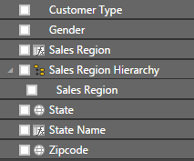

* 1. Right-click **Sales Region Hierarchy,** select the **Rename** menu command and rename the hierarchy **Customer Geography**.

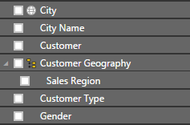

* 1. Right-click on the **State** field and select the **Add to Customer Geography** menu command.
  2. Right-click on the **City** field and select the **Add to Customer Geography** menu command.
  3. Right-click on the **Zipcode** field and select the **Add to Customer Geography** menu command.
  4. The **Customer Geography** hierarchy should now contain four fields as shown in the following screenshot.

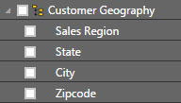

1. Create a new report page and rename it to **Customer Geography Drilldown**.



1. Add a new stacked bar chart visual.
   1. Click the **Stacked Bar Chart** button on the **Visualizations** list to create a new bar chart visual.

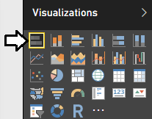

* 1. Resize the bar chart visual so it takes up the entire height and width of the report page.
  2. Drag and drop the **Customer Geography** hierarchy from the **Customers** table into the **Axis** well.
  3. Drag and drop the **Sales Revenue** field from **Sales** table into the **Value** well.
  4. The bar chart should now appear like the one shown in the following screenshot.

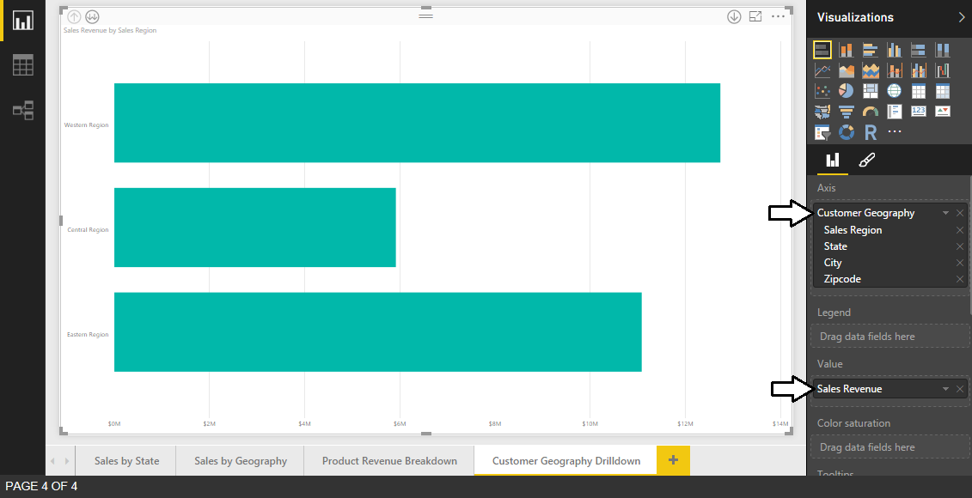

1. Configure **Tooltips** for the bar chart to additionally show **Unit Sold** and **Customer Count**.
   1. Drag and drop the **Units Sold** field from the **Sales** table into the **Tooltips** well.
   2. Drag and drop the **Customer Count** field from the **Sales** table into the **Tooltips** well.
   3. Hover over a bar with the mouse to observe the effects of the new tooltip configuration.

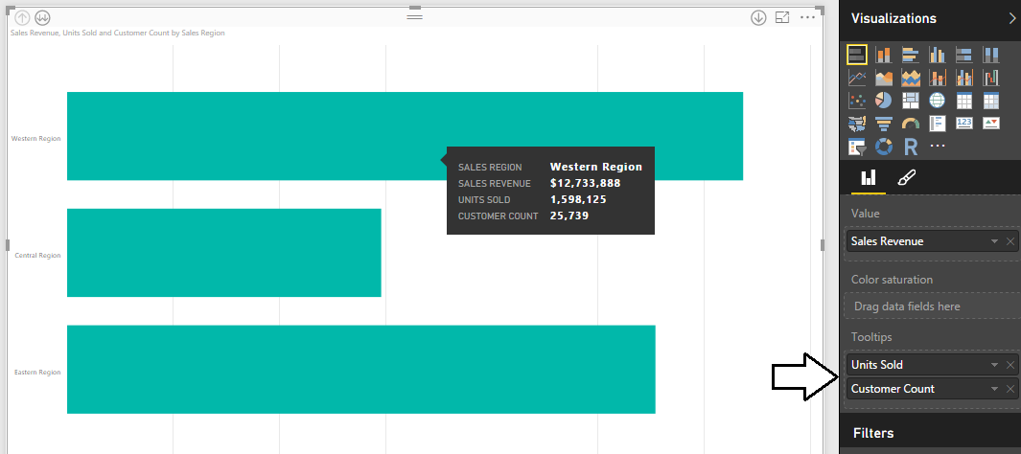

1. Configure **Data labels** for bars inside the bar chart.
   1. Make sure the bar chart visual is selected.
   2. Navigate to the **Format** properties pane and expand the **Data labels** section.
   3. Set the primary **Data labels** setting from **Off** to **On**.
   4. Update the **Display Units** property to **Thousands**.
   5. Set the Text Size to **14 pt**.

.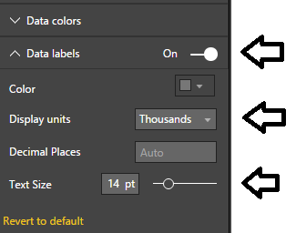

* 1. The bar chart should now display a data label for each bar showing total sales revenue.

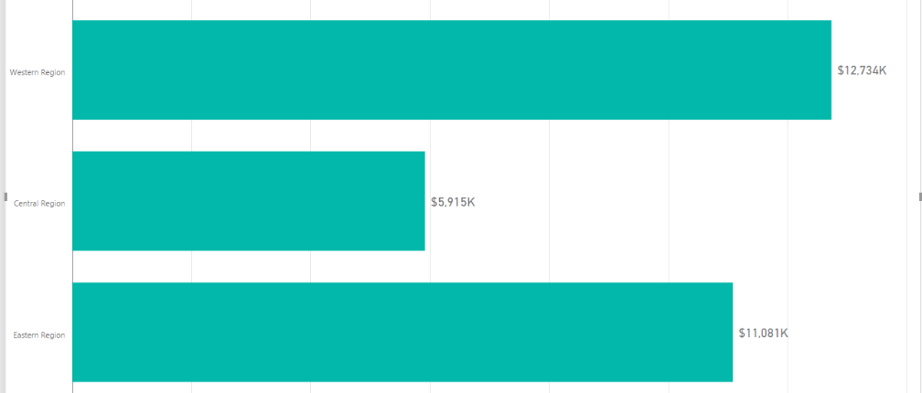

1. Turn on drill down mode for the bar chart visual.
   1. Locate the **Drill Down** button with the downward pointing arrow and the circle around it in the top right corner of the visual.
   2. Click on the **Drill Down** button once to enable drill down mode.

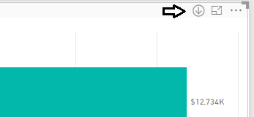

* 1. Once you have enabled drill down mode, the Drill Down button appears as a dark circle with a white arrow.

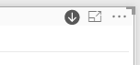

1. Experiment with drill down mode by drilling into the **Customer Geography** hierarchy.
   1. Click on the bar for the **Western Region** to drill down into the states for that sales region.

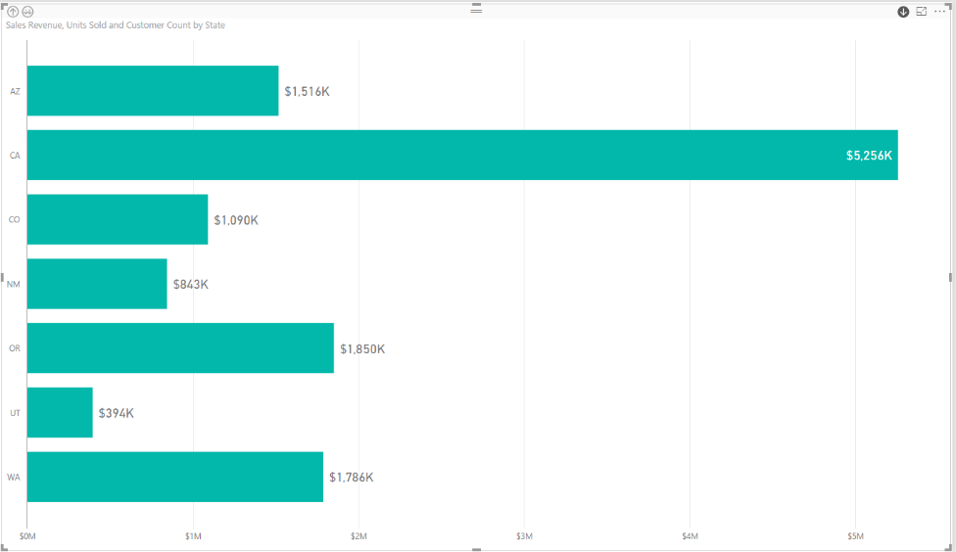

* 1. Click on the bar for the **CA** to drill down into the cities in California.

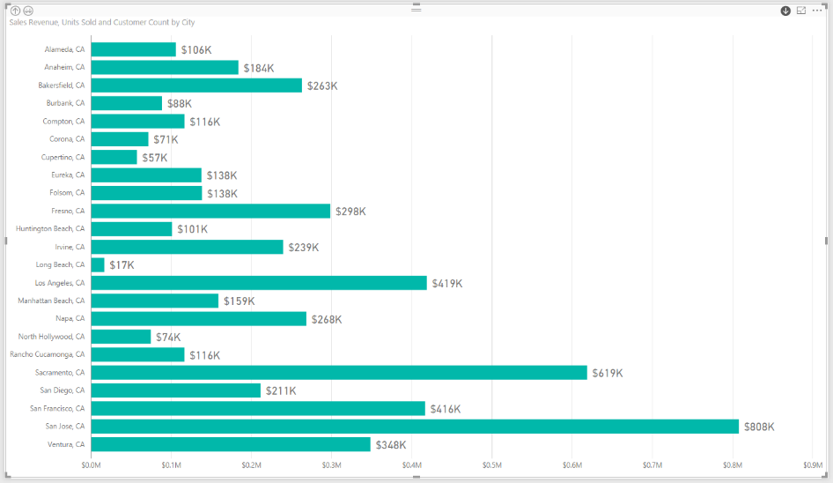

* 1. Click on the bar for a city such as **Los Angeles, CA** to drill down into the zipcodes for that city.

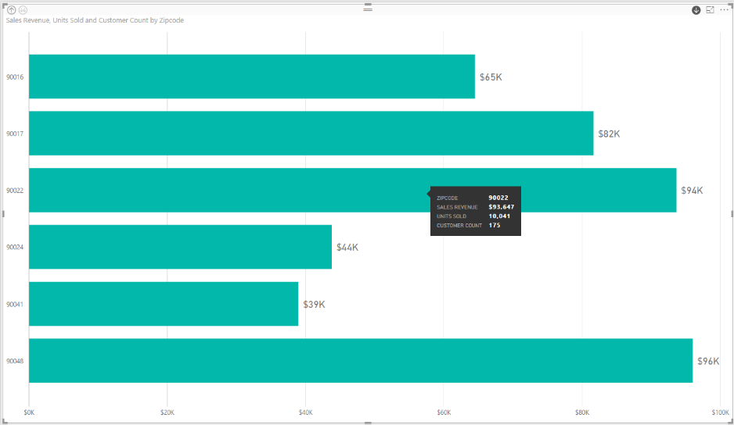

* 1. In the top left corner is a **Drill Up** button. Click on this button three times to return to the top level of the hierarchy.

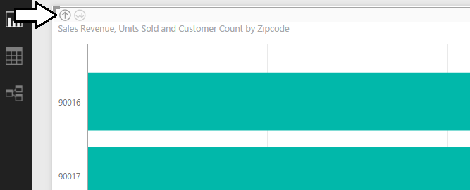

You have now seen how you can set up a visual to drill into and out of a dimensional hierarchy.

### Exercise 7: Extend the Data Model by Adding a Calendar Dimension Table

In this exercise you will create a calculated table named **Calendar** which will play the role of a time dimension table in the data model. The motivation for adding a time dimension table to your data model is that it will allow you to take advantage of the time intelligence support that is built into Power Pivot and DAX.

1. Create a new calculated table named **Calendar**.
   1. Navigate to the **Modeling** tab in the ribbon.
   2. Click the **New Table** button in the ribbon.

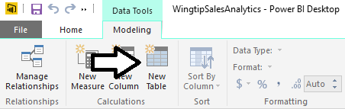

* 1. Type the following DAX formula into the formula bar and press the **Enter** key to create the **Calendar** table.

Calendar =

CALENDAR(

DATE( 2012, 1, 1),

Date( 2015, 12, 31)

)

* 1. You should be able to verify that the **Calendar** table has been created with a single column named **Date**. You should also be and to verify that there is one row in the **Calendar** table for each day in the calendar years of 2012, 2013, 2014 and 2015.

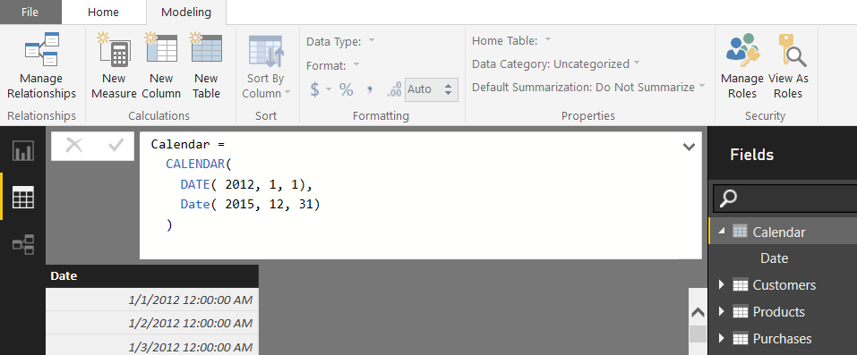

* 1. Modify the DAX expression for this calculated table so you do not have to hardcode literal values for the starting year or the ending year. First, replace the literal value for the starting year 2012 with the following DAX expression.

YEAR( MIN(Sales[PurchaseDate]) )

* 1. Next, replace the literal value for the ending year 2015 with the following DAX expressions.

YEAR( MAX(Sales[PurchaseDate]) )

* 1. At this point, your DAX expression to create the **Calendar** table should now match the following code listing.

Calendar =

CALENDAR(

DATE( YEAR( MIN(Sales[PurchaseDate]) ), 1, 1),

Date( YEAR( MAX(Sales[PurchaseDate]) ), 12, 31)

)

* 1. The **Calendar** table should continue to look as it did before starting at **1/1/20012** and running to **12/31/2015**.

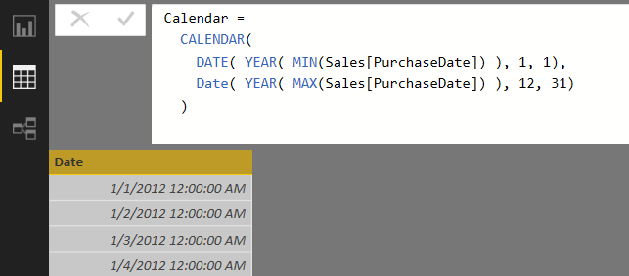

The modification to the DAX expression to calculate the start date and end date dynamically provides flexibility. The new expression will now automatically add new rows for complete years if the **Sales** table is ever updated with purchases that occurred either before the start of 2012 or after the end of 2015.

1. Change the type and format of the **Date** column.
   1. Select the **Date** column by clicking its column header.
   2. Activate the **Modeling** tab of the ribbon.
   3. Set the **Data Type** property to **Date**.
   4. Set the **Format** property to **03/14/2001 (MM/dd/yyyy)**.

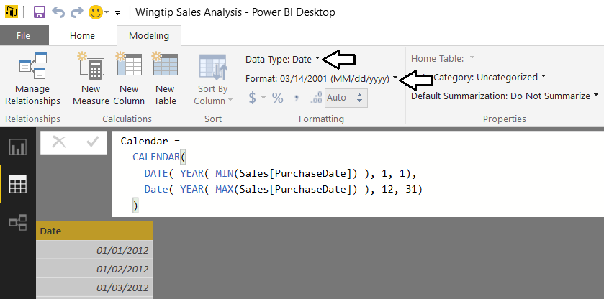

1. Add a new column to the **Calendar** table named **Year** which displays the financial year.
   1. Create a new calculated column by clicking the **New Column** button in the ribbon.

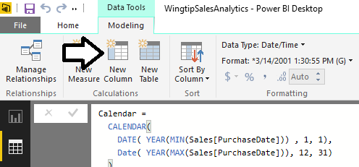

* 1. Type in the following DAX expression and press the Enter key.

Year = YEAR('Calendar'[Date])

* 1. You should see that the **Calendar** table now contains a **Year** column displaying the year.

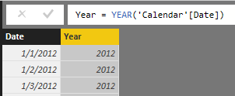

* 1. Modify the **Default Summarization** property of the **Year** column to **Do Not Summarize**.

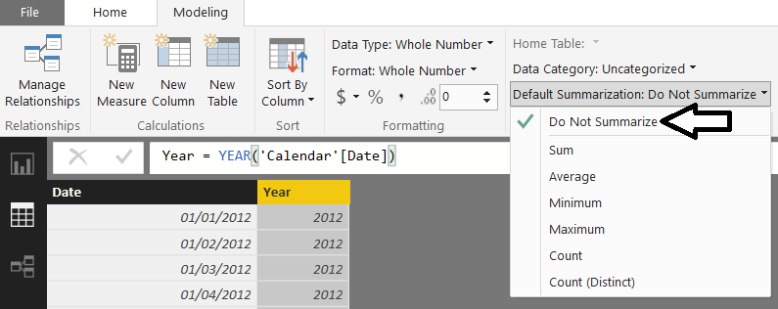

While the **Year** column contains numeric values, it doesn’t make sense to perform standard aggregations on this column such as **Sum**, **Average** or **Count**. Setting the column’s **Default Summarization** to **Do Not Summarize** will prevent Power BI Desktop from automatically assigning aggregate operations when this field is added to a visual in a report.

1. Add a new column to the **Calendar** table named **Quarter** which display the financial year and quarter.
   1. Create a new calculated column by clicking the **New Column** button in the ribbon.
   2. Type in the following DAX expression and press the Enter key.

Quarter = YEAR('Calendar'[Date]) & "-Q" & FORMAT('Calendar'[Date], "q")

* 1. The **Quarter** column now displays a value with the year and quarter which can be used in visuals and reports.

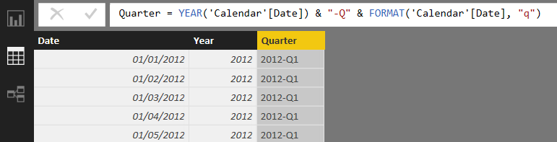

1. Add a new column to the **Calendar** table named **Month** which displays the financial year and month.
   1. Create a new calculated column by clicking the **New Column** button in the ribbon.
   2. Type in the following DAX expression and press the Enter key.

Month = FORMAT('Calendar'[Date], "MMM yyyy")

* 1. The column should now display a month for each date as shown in the following screenshot.

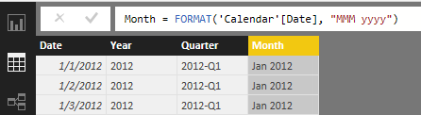

The **Month** column is a good example of a column whose value will not automatically be sorted in the chronological sort order. The default sort order of a text column like **Month** is to sort month names alphabetically so that April will sort before February, and February will sort before January. Therefore, you will now create an addition column named **MonthSort** whose sole purpose will be to provide assistance to the **Month** column to sort its values chronologically.

1. Add a new sort column to the **Calendar** table named **MonthSort** to control the sort order of the **Month** column.
   1. Create a new calculated column by clicking the **New Column** button in the ribbon.
   2. Type in the following DAX expression and press the Enter key.

MonthSort = FORMAT('Calendar'[Date], "yyyy-MM")

* 1. You should be able to see that the **MonthSort** column produces a text value for each date in the format of **2012-01**. The key aspect of this format is that **MonthSort** values are sorted chronologically when they are sorted alphabetically.

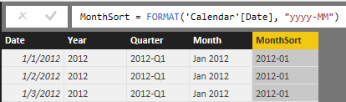

* 1. Configure the **Month** column to use the **MonthSort** column as its sort column. Accomplish this by clicking the column header of the **Month** column to select it and then by dropping down the **Sort By Column** menu button in the ribbon and selecting the **MonthSort** column.

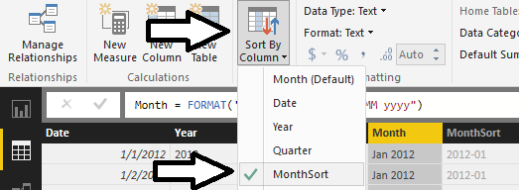

* 1. Hide the **MonthSort** column by right-clicking it on the **Fields** list and selecting the **Hide in Report View** menu command.

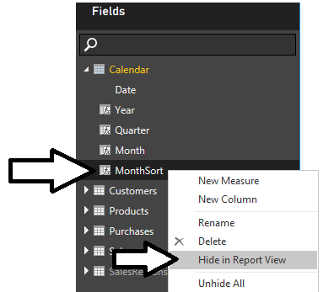

1. Add a new column to the **Calendar** table named **Month in Year** to display the financial month without the year.
   1. Create a new calculated column by clicking the **New Column** button in the ribbon.
   2. Type in the following DAX expression and press the Enter key.

Month in Year = FORMAT('Calendar'[Date], "MMM")

* 1. The **Month in Year** column should now display the abbreviated month name for each date.

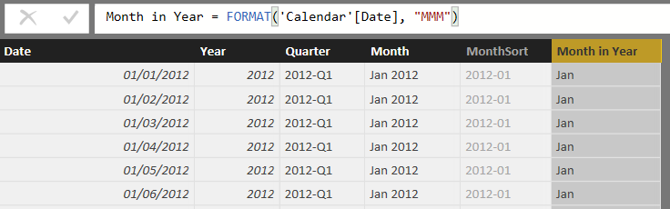

Just like the **Month** column, the **Month in Year** column will need the assistance of a sort column.

1. Add a new sort column to the **Calendar** table named **MonthInYearSort** to control the sort order of the **Month in Year** column.
   1. Create a new calculated column by clicking the **New Column** button in the ribbon.
   2. Type in the following DAX expression and press the Enter key.

MonthInYearSort = MONTH('Calendar'[Date])

* 1. As you can see, the **MonthInYearSort** column displays an integer value between 1 and 12 to indicate the month.

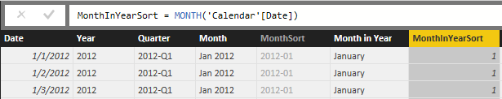

* 1. Configure the **Month in Year** column to use the **MonthInYearSort** column as its sort column. Accomplish this by clicking the column header of the **Month in Year** column to select it and then by dropping down the **Sort By Column** menu button in the ribbon and selecting the **MonthInYearSort** column.

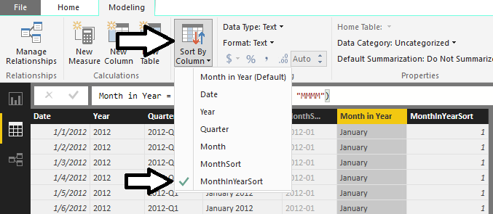

* 1. Hide the **MonthInYearSort** column by right-clicking it in the **Fields** list and selecting the **Hide in Report View** command.

1. Add a new column to the **Calendar** table named **Day of Week** which display the day of the week.
   1. Create a new calculated column by clicking the **New Column** button in the ribbon.
   2. Type in the following DAX expression and press the Enter key.

Day of Week = FORMAT('Calendar'[Date], "ddd")

* 1. The **Day of Week** column should now display the name of the day (e.g. Monday) for each date.

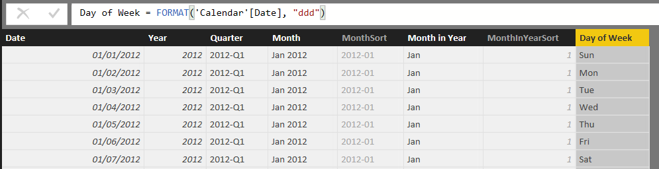

1. Add a new sort column to the **Calendar** table named **DayOfWeekSort** to control the sort order of the **Day of Week** column.
   1. Create a new calculated column by clicking the **New Column** button in the ribbon.
   2. Type in the following DAX expression and press the Enter key.

DayOfWeekSort = WEEKDAY('Calendar'[Date], 2)

The second argument passes to **WEEKDAY** function determines the starting day for the week. If you pass a value of 1, the starting day for the week will be Sunday. In this case you have passed a value of 2 which will make Monday the first day of the week.

* 1. Now the **DayOfWeekSort** column should return an integer value for each date indicating the day of the week. As you can see, each date that is a Monday has a value of 1.

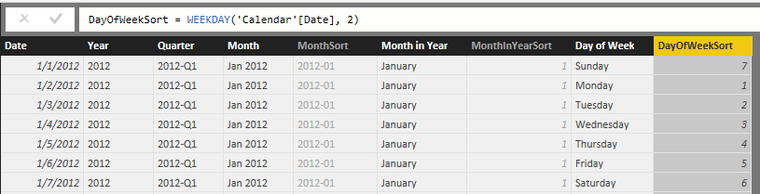

* 1. Configure the **Day of Week** column to use the **DayInWeekSort** column as its sort column. Accomplish this by clicking the column header of the **Day of Week** column to select it and then by dropping down the **Sort By Column** menu button in the ribbon and selecting the **DayInWeekSort** column.

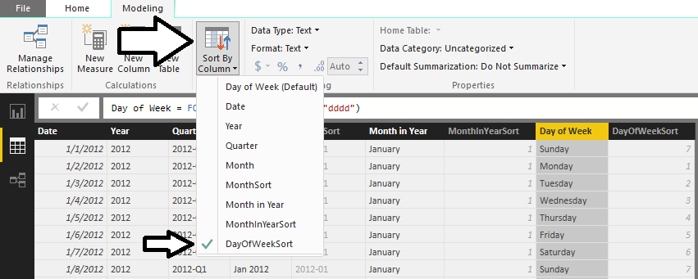

* 1. Hide the **DayInWeekSort** column by right-clicking it in the **Fields** list and selecting the **Hide in Report View** command.

At this point, you have created the **Calendar** table and added all the columns that it requires. The next step to integrate the **Calendar** table into the data model will be to create a relationship between the **Calendar** table and the **Sales** table.

1. Create a relationship between the **Calendar** table and the **Sales** table.
   1. Navigate to relationship view. You should be able to see that the **Calendar** table is present. You should also be able to verify that the **Calendar** table does not have any existing relationships.
   2. Using the mouse, rearrange the tables in relationship view to match the following screenshot where the **Calendar** table is positioned directly below the **Products** table and to the immediate right of the **Sales** table.

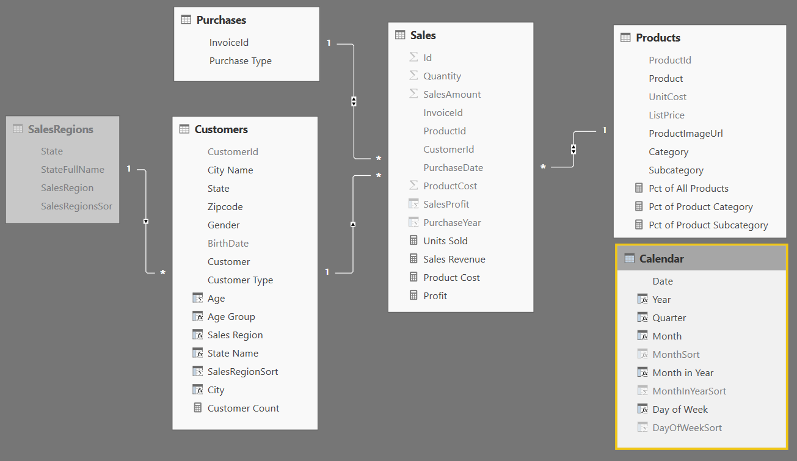

* 1. Create a new relationship by performing a drag and drop operation with the mouse to drag the **PurchaseDate** column from the **Sales** table and dropping it on the **Date** column of the **Calendar** table.

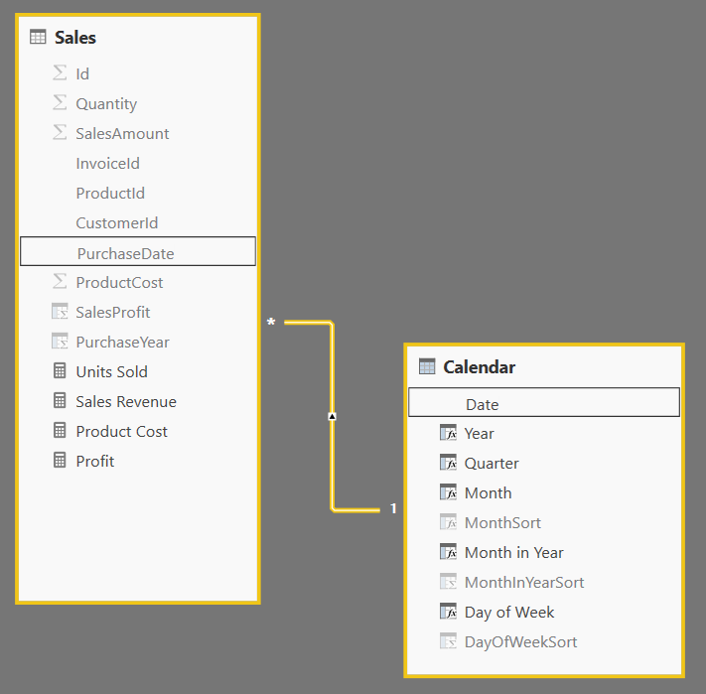

You have now completed the work of adding the **Calendar** table to the data model. Now, you will modify the **Calendar** table to add a new dimension hierarchy named **Calendar Drilldown**.

1. Add a new dimensional hierarchy to the **Calendar** table.
   1. Use the left navigation to switch to Report View.
   2. Inspect the **Calendar** table in the fields list. It should appear as the one shown in the following screenshot.

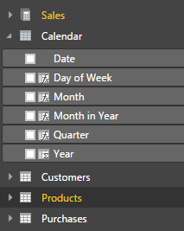

* 1. Right-click on the **Year** field and then select the **New Hierarchy** menu command.

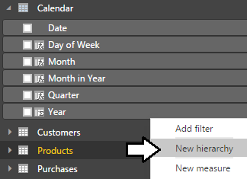

* 1. You should now see a new dimensional hierarchy in the fields list named **Year Hierarchy**.
  2. Right-click **Year Hierarchy** and select the **Rename** menu command.
  3. Rename the new hierarchy **Calendar Drilldown**.

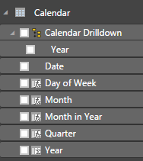

* 1. Right-click on the **Quarter** field and select the **Add to Calendar Drilldown** menu command.
  2. Right-click on the **Month** field and select the **Add to Calendar Drilldown** menu command.
  3. The **Calendar Drilldown** hierarchy should now contain three fields as shown in the following screenshot.

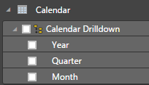

Now you have finished creating the **Calendar** table and you can use it to create reports and to call DAX time intelligence functions.

### Exercise 8: Design Reports and Visuals using the Calendar Table

In this exercise, you will leverage the **Calendar** table that you created in the previous exercise by creating a few new visuals to display sales revenue totals aggregated over various time intervals.

1. Create a new page in the project’s report.
   1. Navigate to report view.
   2. Add a new page by clicking the (**+**) button on the right side of the page navigation menu.
   3. Once the new page has been created, modify its title to **Sales by Time Period**.



* 1. Now that you have created a new page, you can now add a few new visuals.

1. Create a new matrix visual to show sales revenue for specific time periods.
   1. Click the **New Visual** button on the ribbon to add a new visual to the page.

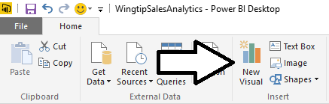

* 1. Change the visual to a matrix by clicking the **Matrix** button in the **Visualizations** list.

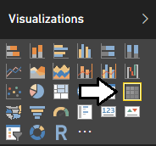

* 1. Select the checkbox next to the **Sales Revenue** measure in the **Fields** list. When you select the **Sales Revenue** measure, the report designer will add it to the **Values** well and the visual will show a single value for total sales revenue across the entire **Sales** table.

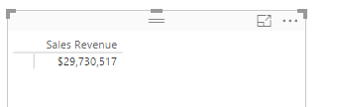

* 1. Now it’s time to extend the matrix by adding row labels and column labels. First, drag and drop the **Year** column from the **Calendar** table in the **Fields** list into the **Rows** well in the **Visualizations** pane.
  2. Now drag and drop the **Month in Year** column from the **Calendar** table in the **Fields** list into the **Columns** well in the **Visualizations** pane.

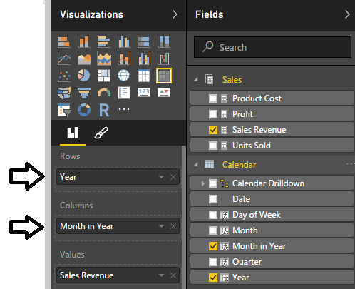

* 1. The matrix now has a column for each month and a row for each year.
  2. Use your mouse to resize the matrix visual so you can see all the columns.

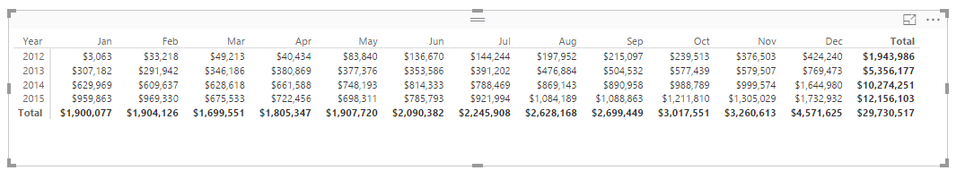

* 1. Now experiment by pivoting the matrix visual to display the exact same data using a different layout. Accomplish this by moving the **Month in Year** field into the **Rows** well and then moving the **Year** field into the **Columns** well. In effect, the **Month in Year** field and the **Year** field have just switched places.

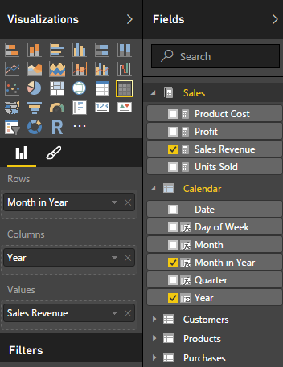

* 1. The matrix should now display a row for each month and a column for each year.

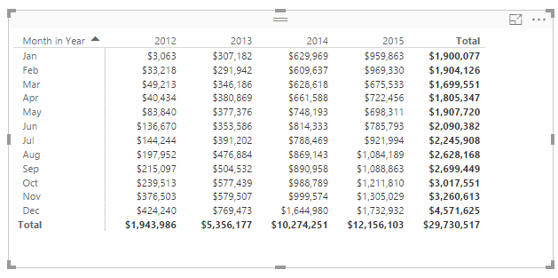

1. Create a new matrix visual to show sales revenue for specific time periods.
   1. Click the **New Visual** button on the ribbon to add a new visual to the page.
   2. Make sure this new visual is positioned directly below the first visual that you created.
   3. Change the visual to a matrix by clicking the Matrix button in the **Visualizations** list.
   4. Drag and drop the **Day of Week** column from the **Calendar** table in the **Fields** list into the **Rows** well.
   5. Drag and drop the **Year** column from the **Calendar** table into the **Columns** well.
   6. Drag and drop the **Sales Revenue** measure from the **Calendar** table in the **Fields** list into the **Values** well.

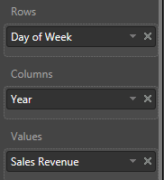

* 1. The matrix should now display a row for each day of the week and a column for each year.

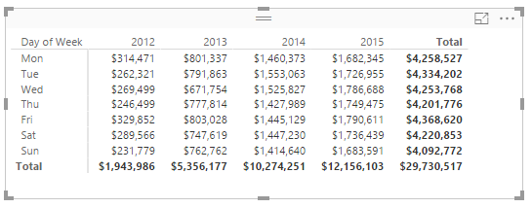

1. Add a third matrix visual to analyze sales data calculated at both the yearly level and the quarterly level.
   1. Click the **New Visual** button on the ribbon to add a new visual to the page.
   2. Change the visual to a matrix by clicking the **Matrix** button in the **Visualizations** list.
   3. Drag and drop the **Year** column from the **Calendar** table into the **Rows** well.
   4. Drag and drop the **Quarter** column from the **Calendar** table into the **Rows** well.

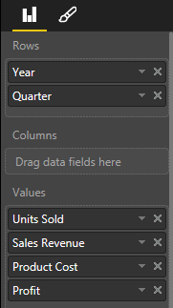

* 1. At this point, the visual has row labels for the **Year** column and the **Quarter** column.

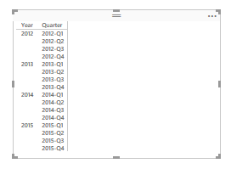

* 1. Drag and drop the **Units Sold** measure from the **Sales** table into the **Values** well.
  2. Drag and drop the **Sales Revenue** measure from the **Sales** table into the **Values** well.
  3. Drag and drop the **Product Cost** measure from the **Sales** table into the **Values** well.
  4. Drag and drop the **Profit** measure from the **Sales** table into the **Values** well.



* 1. The matrix should now display values for each measure calculated at the quarterly level as well as at the yearly level.

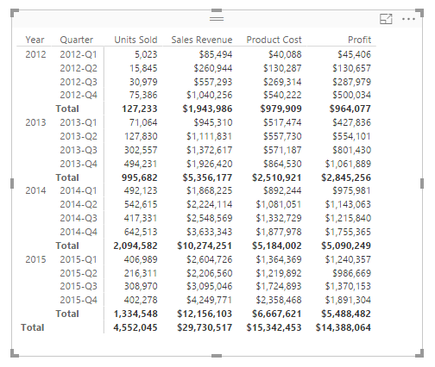

* 1. Using your mouse, arrange the new matrix visual on the right side of the page at the top to match the following screenshot.

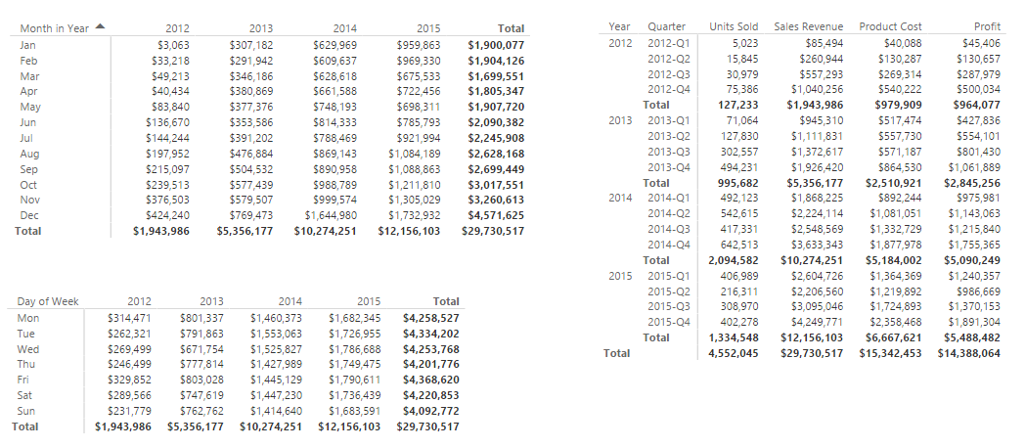

1. Save the work you have done by clicking the **Save** button in the upper left corner of the Power BI Desktop window.

### Exercise 9: Create Measures using DAX Time Intelligence Functions

In this exercise, you will leverage various the Time Intelligence functions in DAX to analyze sales revenue using quarter to date (QTD) totals and year to date (YTD) totals. You will also use DAX to write an expression which calculate a running total of sales revenue through the entire 4 years of sales activity.

1. Create a measure named **Sales Revenue QTD** that calculates a quarter-to-date aggregate sum on the **SalesAmount** column of the **Sales** table.
   1. Navigate to data view.
   2. Select the **Sales** table from the **Fields** list.
   3. Create a new measure by clicking the **New Measure** button in the ribbon.



* 1. Enter to following DAX expression into the formula bar to create the new measure named **Sales Revenue QTD**.

Sales Revenue QTD = TOTALQTD( SUM(Sales[SalesAmount]), 'Calendar'[Date])

* 1. Press the **ENTER** key to add the measure to data model.
  2. Modify the formatting by dropping down the **Format** menu on the ribbon and selecting **Currency > English (United States)**. Also use the spinner control below the **Format** menu to set the number of decimal places shown to zero.

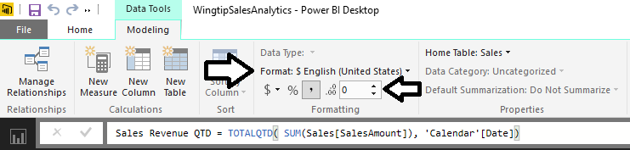

1. Create a measure named **Sales Revenue YTD** that calculates a year-to-date aggregate sum on the **SalesAmount** column of the **Sales** table.
   1. Navigate to data view.
   2. Select the **Sales** table from the **Fields** list.
   3. Create a new measure by clicking the **New Measure** button in the ribbon.
   4. Enter to following DAX expression into the formula bar to create the new measure named **Sales Revenue YTD**.

Sales Revenue YTD = TOTALYTD( SUM(Sales[SalesAmount]), 'Calendar'[Date])

* 1. Press the **ENTER** key to add the measure to data model.
  2. Modify the formatting by dropping down the **Format** menu on the ribbon and selecting **Currency > English (United States)**. Also use the spinner control below the **Format** menu to set the number of decimal places shown to zero.

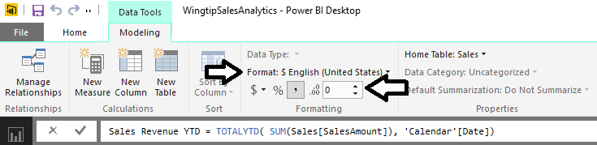

1. Create a measure named **Sales Revenue RT** that calculates a running total aggregate sum on the **SalesAmount** column of the **Sales** table.
   1. Navigate to data view.
   2. Select the **Sales** table from the **Fields** list.
   3. Create a new measure by clicking the **New Measure** button in the ribbon.
   4. Enter to following DAX expression into the formula bar to create the new measure named **Sales Revenue RT**.

Sales Revenue RT =

CALCULATE(

SUM(Sales[SalesAmount]),

FILTER(

ALL('Calendar'),

'Calendar'[Date] <= MAX('Calendar'[Date])

)

)

* 1. Press the **ENTER** key to add the measure to data model.
  2. Modify the formatting by dropping down the **Format** menu on the ribbon and selecting **Currency > English (United States)**. Also use the spinner control below the format menu to set the number of decimal places shown to zero.

1. Use the three new measures in a matrix visual.
   1. Navigate to report mode and make sure the **Sales by Time Period** report page is active.
   2. Select the matrix visual you created last that is currently positioned on the right-hand side of the page.
   3. Examine the bottom of the **Visualizations** pane. Currently, the **Rows** well contains the **Year** column and the **Quarter** column. There are also four other measures in the **Values** well.



* 1. Remove all the measures from the **Values** well except for the **Sales Revenue** measure. At this point, your visual should match the one shown in the following screenshot where sales revenue totals as shown at the quarterly level and at the yearly level.

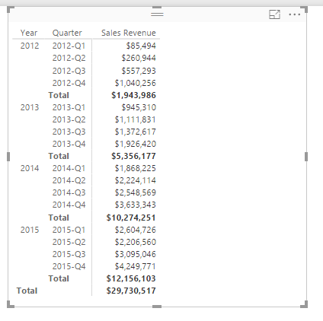

* 1. Drag and drop the **Month** column from the **Calendar** table into the **Rows** well below the two other columns.

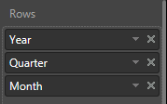

* 1. You should be able to see that now the visual now has a deeper level of granularity because it is show sales revenue broken out into a separate aggregate value for each month.

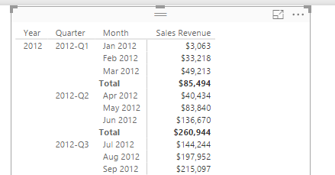

* 1. Set a filter on the matrix visual so that is only displays sales revenue for the calendar years of 2014 and 2015. Accomplish this by setting a filter where the **Year** column is greater than or equal to **2014**.

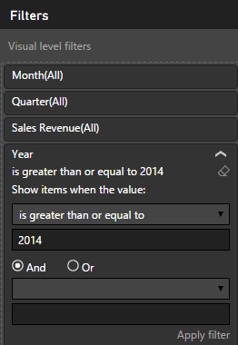

* 1. After setting the filter, click the **Apply Filter** link below to apply your filter to the data shown in the visual.
  2. Resize the matrix visual to take up the entire right-hand side of the page.

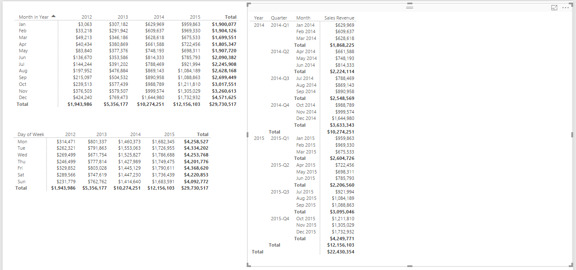

* 1. Drag and drop the **Sales Revenue QTD** measure from the **Sales** table into the **Values** well.
  2. Drag and drop the **Sales Revenue YTD** measure from the **Sales** table into the **Values** well.
  3. Drag and drop the **Sales Revenue RT** measure from the **Sales** table into the **Values** well.

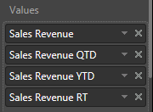

* 1. The matrix visual should now display three new columns for the three measure you added to the **Values** well.

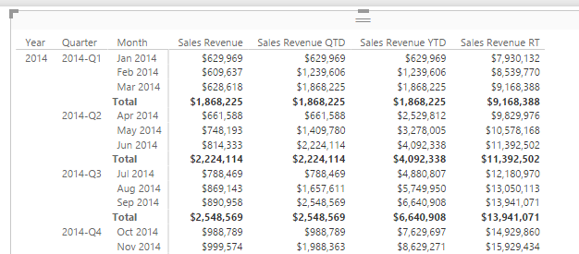

* 1. Currently the matrix is showing a **Total** row with a quarterly rollup. You should observe that the **Total** row can be confusing with measures like these because the it displays the exact same aggregate value as the row above it.

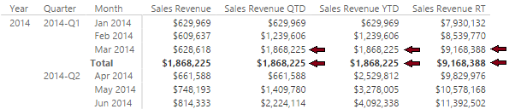

* 1. Look inside the **General** section for the visual in the **Visualizations** pane and set modify the **Row totals** property to **Off**.

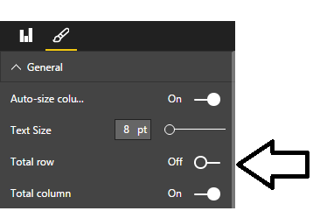

* 1. The matrix visual is now better suited to display the three new measures you created in this exercise.

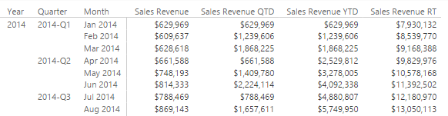

* 1. Now imagine your boss asks you to determine in what month the company reached 10 million dollars in total sales revenue. By looking at down the list of values for the **Sales Revenue RT** measure, you can see that the company finally hit $10,000,000 in sales revenue in May of 2014.

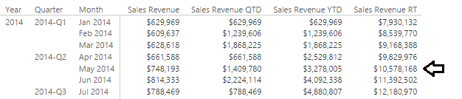

1. Save the work you have done by clicking the **Save** button in the upper left corner of the Power BI Desktop window.

You have now learned how to use Time Intelligence functions in DAX together with a calendar table. Now you will move on to the final exercise where you will create additional measures to monitor sales growth.

### Exercise 10: Create Measures to Monitor Growth in Sales Revenue

In this exercise you will create new measures to calculate the growth of sales revenue on a month-by-month basis. After that you will create additional measures that will act as KPIs to monitor the health of sales growth and provide visual indications as to how each month has done when compared to the previous month.

1. Create a measure named **Sales Growth PM** that calculates the percentage increase between sales revenue for the current month and sales revenue for the previous month.
   1. Navigate to data view.
   2. Select the **Sales** table from the **Fields** list.
   3. Create a new measure by clicking the **New Measure** button in the ribbon.



* 1. Enter to following DAX expression into the formula bar to create the measure named **Sales Growth PM**.

Sales Growth PM =

DIVIDE(

SUM(Sales[SalesAmount]) -

CALCULATE(

SUM(Sales[SalesAmount]),

PREVIOUSMONTH(Calendar[Date])

),

CALCULATE(

SUM(Sales[SalesAmount]),

PREVIOUSMONTH(Calendar[Date])

)

)

* 1. Press the **ENTER** key to add the calculated column to data model.
  2. Modify the formatting by dropping down the **Format** menu on the ribbon and selecting **Percentage**. Also use the spinner control below the **Format** menu to set the number of decimal places shown to **2**.

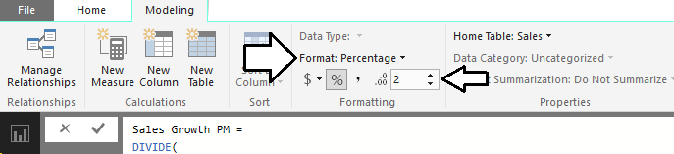

1. Create a new page in the project’s report.
   1. Navigate to report view.
   2. Add a new page by clicking the (**+**) button on the right of the page navigation menu.
   3. Once the new page has been created, modify its title to **Sales Revenue Growth**.



1. Create a new matrix visual to show month-to-month sales revenue growth in 2014 and 2015.
   1. Click the **New Visual** button on the ribbon to add a new visual to the page.
   2. Change the visual to a matrix by clicking the **Matrix** button in the **Visualizations** list.
   3. Drag and drop the **Calendar Drilldown** column hierarchy from the **Calendar** table into the **Rows** well.
   4. Drag and drop the **Sales Revenue** measure from the **Sales** table into the **Value** well.
   5. Drag and drop the **Sales Growth PM** measure from the **Sales** table into the **Value** well.
   6. The **Rows** well and the **Values** well for the matrix visual should match the following screenshot.

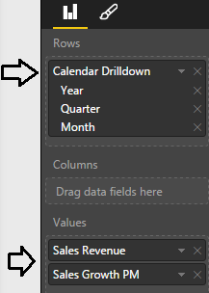

* 1. Move down in the **Visualizations** page to the **Filters** section. Set a filter for **Year** where value is greater or equal 2014.

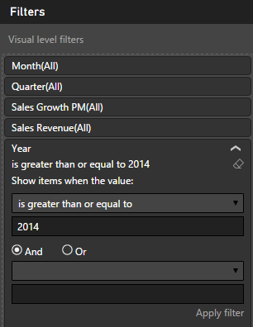

* 1. Click the **Apply filter** button at the bottom of the **Filters** section for the filter to take effect.
  2. Use your mouse to resize the matrix visual so you can see all the rows and columns. Give the matrix visual a width that is half the width of the page so you can add additional columns over the next few steps without having to resize the visual again.

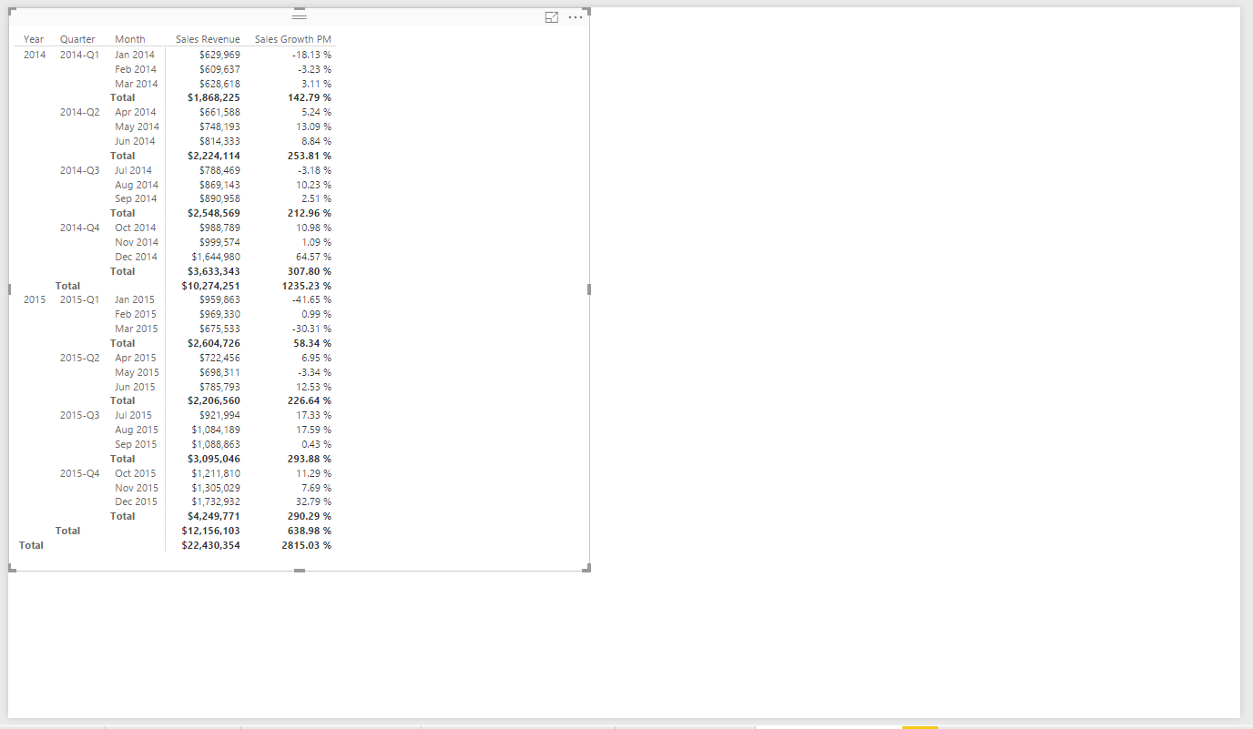

* 1. Inspect the values produced by the **Sales Growth PM** measure. You can see that a value has been calculated for each month. You should also notice that the matrix currently displays values for the **Sales Growth PM** measure in the **Total** row. The values in the **Total** row are calculated at the quarterly level and not at the month level.

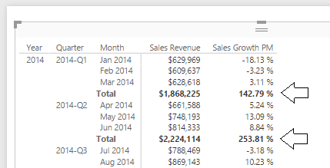

The **Sales Growth PM** measure was written to perform calculations on a month-to-month basis. However, there is currently a problem whenever this measure is evaluated in a context based on a larger time interval such as a quarter or a year. More specifically, the **Sales Growth PM** measure is currently producing a large and erroneous value when it is evaluated in the context of a quarter. Now that you have seen the problem, it’s time to modify the DAX expression for the **Sales Growth PM** measure to return a blank value whenever the measure is evaluated in a context where the time interval is at a granularity other than at the monthly level.

1. Modify the DAX expression for the **Sales Growth PM** measure.
   1. Navigate to data view.
   2. Select the **Sales Growth PM** measure of the **Sales** table from the **Fields** list. When you select the **Sales Growth PM** measure in the **Fields** list, you should then be able to see and modify its DAX expression in the formula bar.
   3. Before you can modify the DAX expression for the **Sales Growth PM** measure, you must be able to use the ISFILTERED function provided by DAX. You can write the following DAX expression to determine whether the current evaluation context is filtering at the month level.

ISFILTERED(Calendar[Month])

* 1. You can also write the following DAX expression to make sure that the current evaluation context is not filtering at a more granular level such as at the **Date** level.

NOT(ISFILTERED(Calendar[Date]))

* 1. You will need to ensure that both these expressions are true before the **Sales Growth PM** measure evaluates to a value other than a blank value. You can write the following DAX expression using the DAX **&&** operator to return true when both inner conditions are true

ISFILTERED(Calendar[Month]) && NOT(ISFILTERED(Calendar[Date]))

* 1. Update the DAX expression for the **Sales Growth PM** measure to match the following code listing.

Sales Growth PM =

IF(

( ISFILTERED(Calendar[Month]) && NOT(ISFILTERED(Calendar[Date])) ),

DIVIDE(

SUM(Sales[SalesAmount]) -

CALCULATE(

SUM(Sales[SalesAmount]),

PREVIOUSMONTH(Calendar[Date])

),

CALCULATE(

SUM(Sales[SalesAmount]),

PREVIOUSMONTH(Calendar[Date])

)

),

BLANK()

)

* 1. Navigate back to report view and inspect the effects of your changes to the visual on the **Sales Revenue Growth** page.
  2. You should see that the **Sales Growth PM** measure is now returning blank values in the **Total** row for the quarterly evaluation.

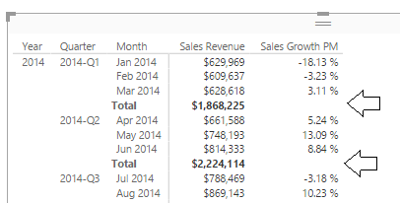

☺ It is widely-accepted among BI experts and BI novices alike that a blank value is always preferable to a large, erroneous value.

1. Create a measure named **Sales Growth PM Eval** that inspects the value of the **Sales Growth PM** measure and evaluates to a short string value to indicate the health of the sales growth value.
   1. Navigate to data view.
   2. Select the **Sales** table from the **Fields** list.
   3. Create a new measure by clicking the **New Measure** button in the ribbon.
   4. Enter to following DAX expression into the formula bar to create the measure named **Sales Growth PM Eval**.

Sales Growth PM Eval =

IF(

ISNUMBER([Sales Growth PM]),

SWITCH(TRUE(),

([Sales Growth PM] >= 0.2), "EXCELLENT",

([Sales Growth PM] >= 0.1), "GOOD",

([Sales Growth PM] >= 0), "OK",

([Sales Growth PM] >= -0.1), "BAD",

([Sales Growth PM] < -0.1), "AWFUL"

)

)

* 1. Navigate to report view and select the matrix visual on the **Sales Revenue Growth** page.
  2. Drag and drop the **Sales Growth PM Eval** measure from the **Sales** table into the **Values** well in the **Visualizations** pane.

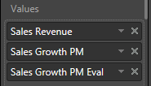

* 1. You should now see values for the **Sales Growth PM Eval** measure which indicate the health of sales revenue growth.

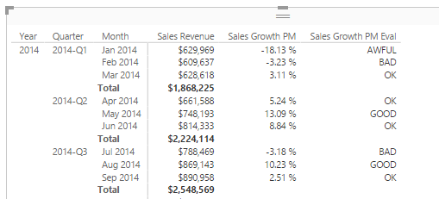

* 1. Inside the **General** section of the Format properties pane, update the **Total row** property from **On** to **Off**.

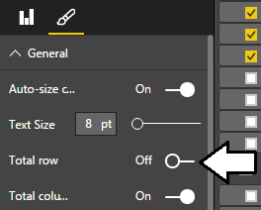

* 1. At the bottom of the **Format** properties pane, update the Border property from **Off** to **On**.

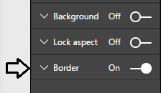

* 1. At this point, the matrix visual you have created should match the following screenshot.

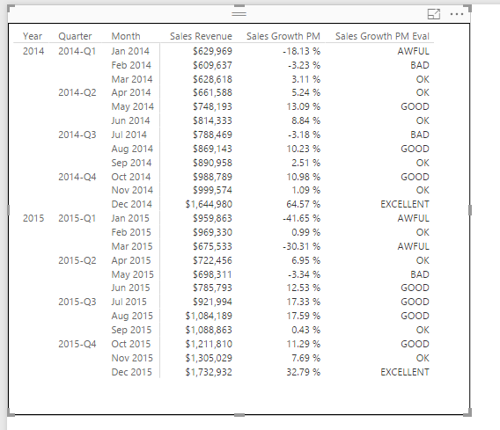

* 1. Save the work you have done by clicking the **Save** button in the upper left corner of the Power BI Desktop window.

1. Clone the matrix visual by copying it to the Windows clipboard and pasting it to make a copy.
   1. Select the matrix visual and copy it to the Windows clipboard.
   2. Perform a paste operation to create an identical copy of the matrix visual.
   3. Position the two visuals side by side to the left as shown in the following screenshot.

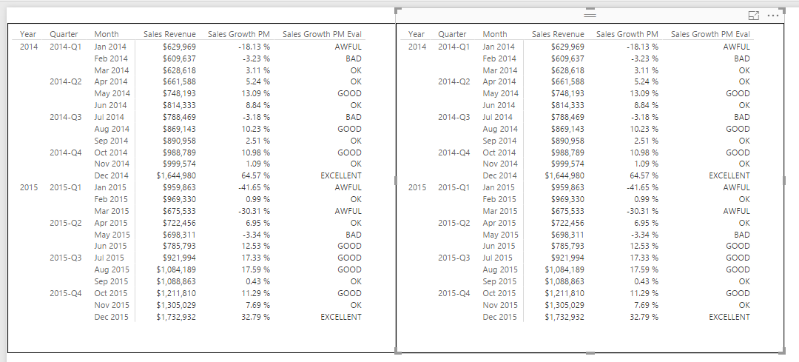

1. Update the matrix visual on the left to display financial data for the years of 2012 and 2013.
   1. Select the matrix visual on the left.
   2. Locate the **Filters** section the **Field** property pane.
   3. Update the filter for the **Year** column where value **is less than or equal to 2013**.

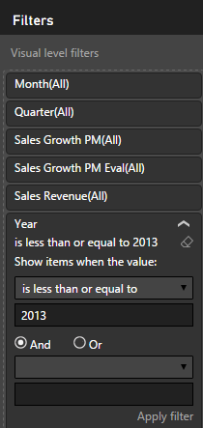

* 1. Click the **Apply filter** button for the filter to take effect.
  2. The visual on the left should now display sales data for years of 2012 and 2013 while the visual on the right display sales data for 2014 and 2015.

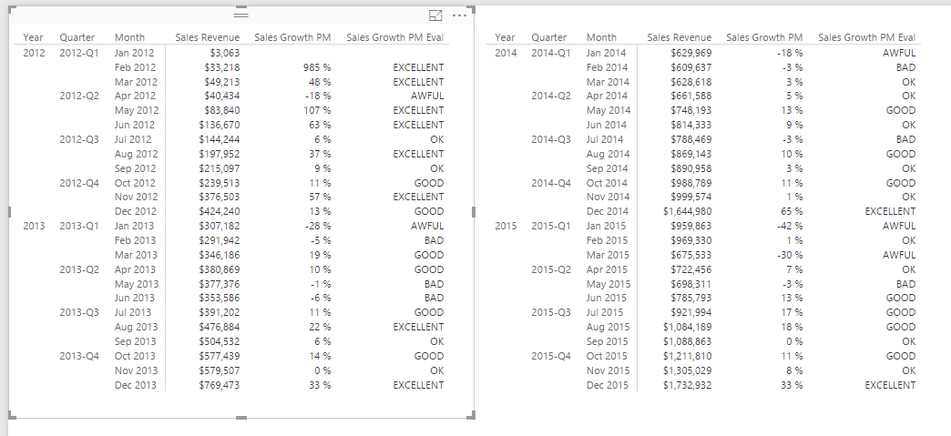

* 1. Save the work you have done by clicking the **Save** button in the upper left corner of the Power BI Desktop window.

1. Add a line chart visual to the bottom of the report page to show how sales revenue has grown from month to month.
   1. Click on the whitespace on the report to make sure that neither of the two visuals are selected.
   2. Click on the Line chart button in the **Visualizations** list to create a new Line chart visual.

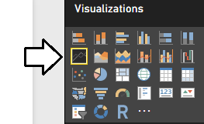

* 1. Reposition the new visual so it takes up the entire width of the page at the bottom of the report.

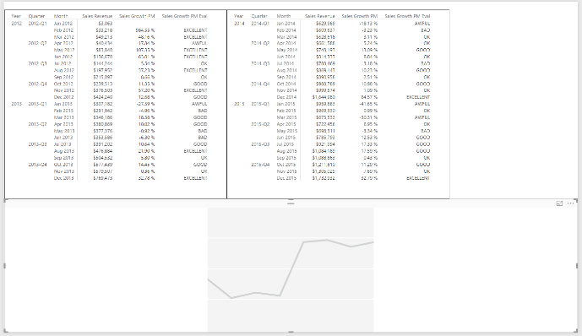

* 1. Drag and drop the **Month** field from the **Calendar** table into the **Axis** well.
  2. Drag and drop the Sales Growth PM field from the sales table into the Values well.

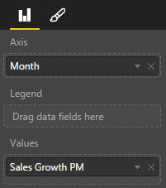

* 1. You should now see a Line chart which shows the month-to-month growth in sales revenue from 2012 through 2015.

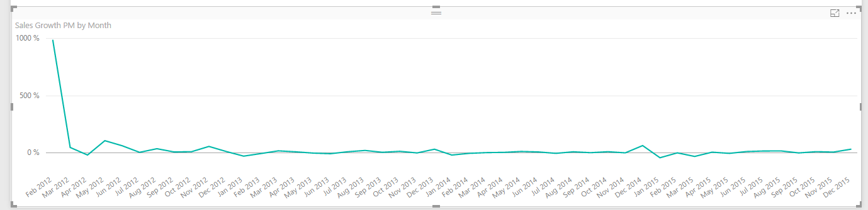

1. Observe the problem with the monthly sales growth in February of 2012.
   1. Examine the sales growth in **Feb 2012** which has a value of 985%

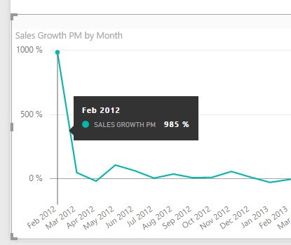

The problem with this sales growth figure for Feb 2012 has to do with the fact that the previous month is not a complete month but instead only contains 4 days of sales data from January 28 to January 31. Over the next few steps you will write more DAX code to add additional logic so that the Sales Growth PM measure returns a blank value when the previous month does not contain all the days for a full month.

1. Create a measure named **Previous Month Is Valid** to indicate whether the previous month is a complete month or not.
   1. Navigate to data view.
   2. Select the **Sales** table from the **Fields** list.
   3. Create a new measure by clicking the **New Measure** button in the ribbon.
   4. Enter to following DAX expression into the formula bar to create the measure named **Previous Month Is Valid**.

Previous Month Is Valid =   
 FIRSTDATE(PREVIOUSMONTH('Calendar'[Date])) >= FIRSTDATE(ALL(Sales[PurchaseDate]))

Note that the new measure named **Previous Month Is Valid** will not be used directly in any report. Instead, you have created this measure to call from the DAX code you write in other measures. Since you will only reference this measure from other measures, it makes sense to hide this measure from report view.

1. Once you have created the **Previous Month Is Valid** measure, right click on it in the fields list and click **Hide in Report View**.
2. Update the DAX code for the **Sales Growth PM** measure to return a blank value when the previous month is incomplete.
   1. Select the **Sales Growth PM** measure so you can see its DAX in the formula editor.
   2. Currently, the **If** statement at the top has two conditions.

( ISFILTERED(Calendar[Month]) && NOT(ISFILTERED(Calendar[Date])) )

* 1. Update the **If** statement to add a third condition to ensure the **Previous Month Is Valid** measure is true.

(

ISFILTERED(Calendar[Month]) &&

NOT(ISFILTERED(Calendar[Date])) &&

[Previous Month Is Valid]

)

* 1. The DAX for the Sales Growth PM measure should now match the following code listing.

Sales Growth PM =

IF(

(

ISFILTERED(Calendar[Month]) &&

NOT(ISFILTERED(Calendar[Date])) &&

[Previous Month Is Valid]

),

DIVIDE(

SUM(Sales[SalesAmount]) -

CALCULATE(

SUM(Sales[SalesAmount]),

PREVIOUSMONTH(Calendar[Date])

),

CALCULATE(

SUM(Sales[SalesAmount]),

PREVIOUSMONTH(Calendar[Date])

)

),

BLANK()

)

1. Return to report view and see the effects of the changes you just made to the **Sales Growth PM** measure. You should see that the spike in the first month is gone and the line chart provides a better view of sales revenue growth of the four years of sales data.

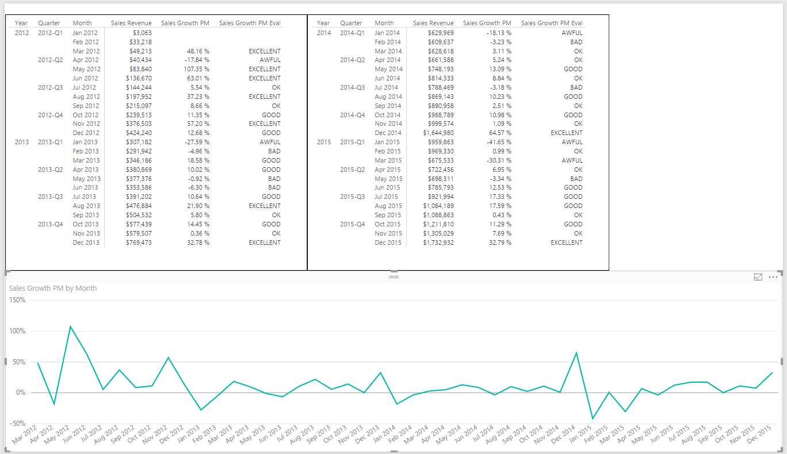

1. Save your work to the **Wingtip Sales Analysis** project by clicking the **Save** button in the ribbon.

Congratulations. You have now reached the end of this lab.